Contents

REQUIREMENT SPECIFICATION – FUNCTIONAL REQUIREMENTS 4

System Use Case Diagram - Fully Automated 4

USE CASE PACKAGES 5

Packages based on similar **FUNCTIONALITY** 5

**Use Case Diagram for each Package:** 6

Actors List and Description: 13

Use cases (Name and Definition) 14

Request Stationery 14

Check Unfulfilled 15

Delegate Authority 15

Approve Request 15

Edit Pick-up 16

Login 16

Generate Trend 17

Issue Adjustment Voucher 17

View Requisition 18

Collect Stationery 18

Raise Purchase Order 19

Make Adjustment 19

View Stock 20

Accept Supply 20

Deliver Request 20

Alert low stock 21

Requirement Specification(Non functional) 21

User Volume 21

Entity volume 22

Use case transaction volume 24

Security requirement and access matrix 25

UI specifications 27

Request Stationary 27

Approve Request 32

Edit Pick-up 34

Delegate Authority 36

View requisition 38

Raise purchase order 39

View stock 39

Accept supply 40

Issue adjustment voucher 40

Make adjustment 42

Deliver Request 46

Collect Stationary 48

State chart 51

RAISE PURCHASE ORDER UI 51

VIEW STOCK UI 51

DELEGATE AUTHORITY 52

REQUEST STATIONARY 52

VIEW DISBURSEMENT LIST 53

Collect Stationary(Screen 12) 53

Retrieval Form(Screen13) 54

Change preference (Screen 7) 54

Delegate authority 55

Login 55

Screen 4 56

Architectural Platform 57

Final Design Sequence Diagram 60

LOGIN 60

APPROVE REQUEST 61

ALERT LOW STOCK 62

CHECK UNFULFILLED 63

RAISE PURCHASE ORDER 64

ISSUE ADJUSTMENT VOUCHER 65

DELEGATE AUTHORITY 66

EDIT PICKUP 67

GENERATE TREND ANALYSIS 68

VIEW REQUSITION 69

VIEW STOCK 70

APPROVE REQUEST 71

DELEGATE AUTHORITY 72

DELIVER REQUEST 73

EDIT PICK UP 74

ISSUE ADJUSTMENT VOUCHER 75

REQUEST STATIONARY 76

ACCEPT SUPPLY 77

MAKE ADJUSTMENT 78

CONSOLIDATED CLASS DIAGRAM 79

UI CLASS DIAGRAM 79

CONTROL CLASS DIAGRAM 80

ENTITY CLASS DIAGRAM 81

Relational DB Design 82

# REQUIREMENT SPECIFICATION – FUNCTIONAL REQUIREMENTS

System Use Case Diagram - Fully Automated 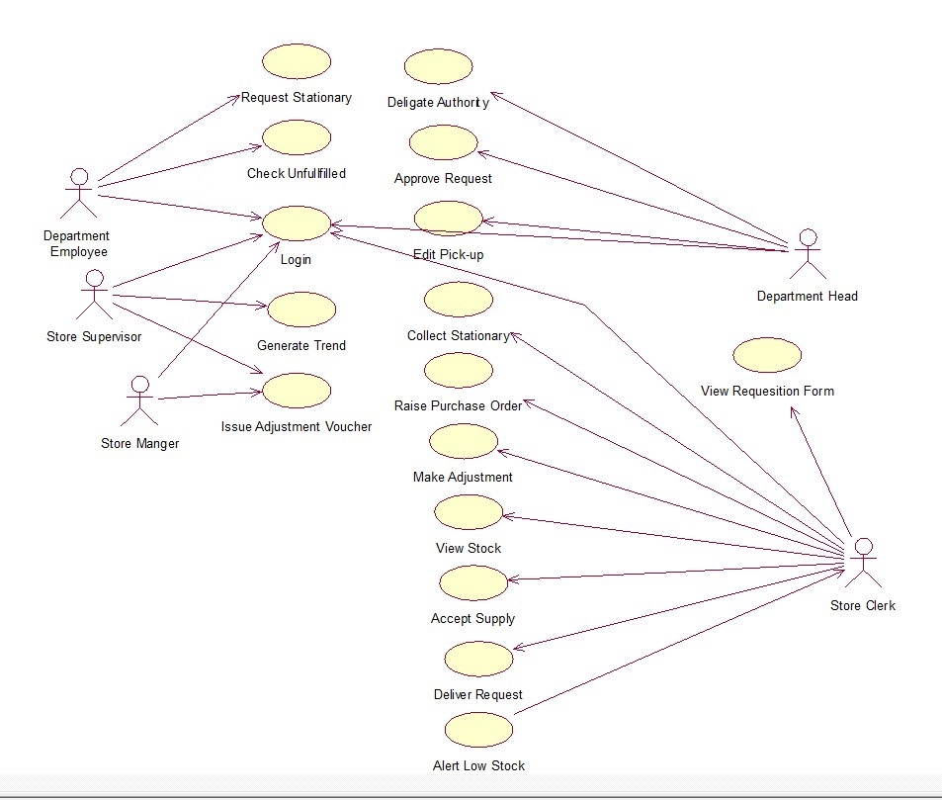

# USE CASE PACKAGES

## Packages based on similar **FUNCTIONALITY**

Authentication

Report

Generate Trend

Delivery

Collect Stationery

Edit Pick-up

Deliver Request

Requisition

Request Stationery

View Requisition

Approve Request

Check Unfulfilled

Order

Stock Adjustment

Make Adjustment

Issue Adjustment Voucher

### **Use Case Diagram for each Package:**

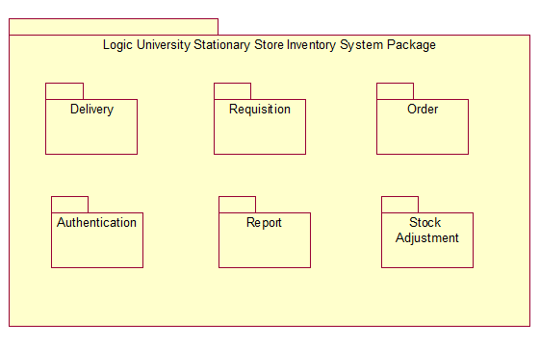

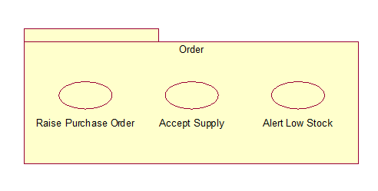

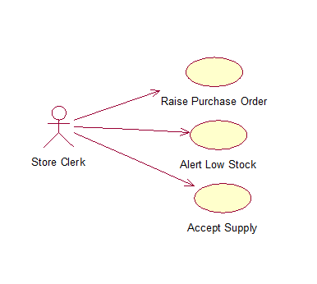

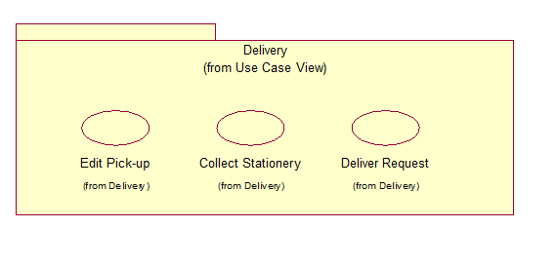

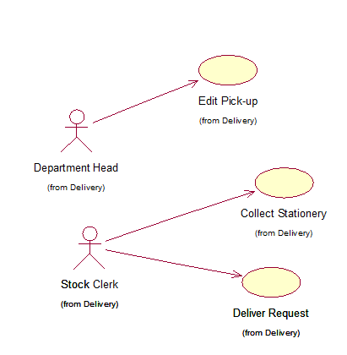

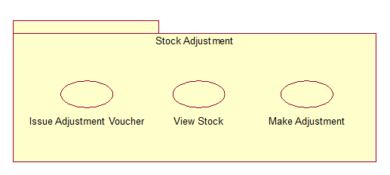

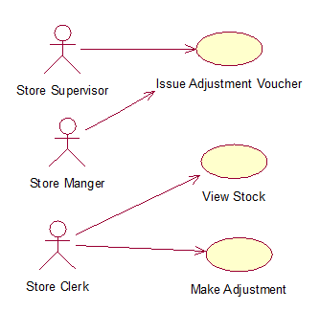

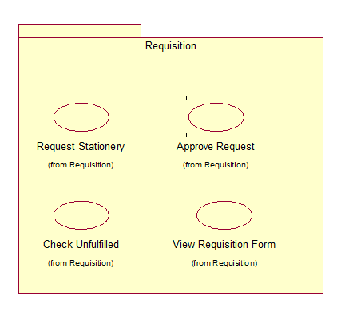

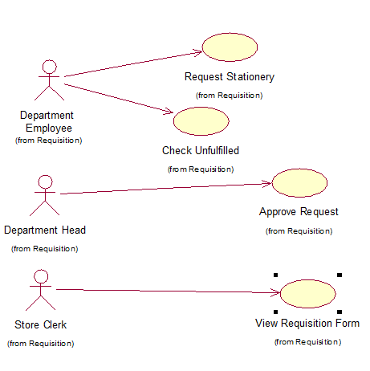

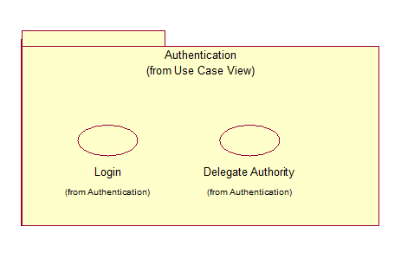

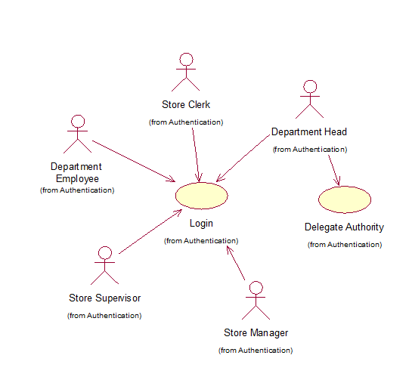

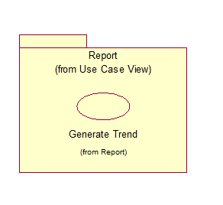

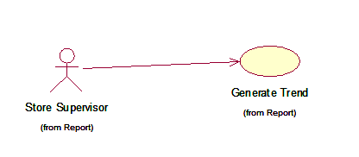

### Actors List and Description:

|  |  |
| --- | --- |
| **Actor** | **Description** |
| Department Head | The head of the department who is in charge of approving the requests made by the department employees. He assigns which department representative can collect stationary at which collection point. He can delegate his duty to another employee during his absence through the system. |
| Department Employee | A staff member of the department who can place orders for stationary online and check the unfulfilled orders, which will be reordered automatically through the system. |
| Store Manager | The main staff of the stationery inventory store, who is in charge of issuing the adjustment voucher for each item with discrepancies that exceeds $250 of adjustment. |
| Store Supervisor | A staff of the stationery inventory store, who is required to generate Reports for Re-order of stationary and Requisition Trend of stationary of the various departments. He is the one who has to inform the store manager in cases of item discrepancies. |
| Store Clerk | A staff of the stationery inventory store, who can view the requisition from various departments, disburse the stationary to the department representatives, keep a note of the product stock and raise purchase orders from different suppliers through the system. |

# Use cases (Name and Definition)

## Request Stationery

**Pre-condition:** The department employee must have internet access to view the products and make a request both on a website and a Mobile application. The mobile app must be installed in his/her device.

**Post-condition:** Once a request has been made it is sent to the respective department head for approval through the system. The employee can exit the request at any time but his cart will still be kept in memory.

**Purpose:** Toallow department employees to order stationery from the store.

**Task list:**

* The System displays the list of all the products.
* The employee can search by description and get a filtered list.
* The employee can select the item, quantity and add it to the cart and delete from cart as well.
* On completion of the request the employee can view the cart and make request.

## Check Unfulfilled

**Pre-condition:** Previously maderequests for certain items that are approved, but could not be fulfilled by the store

**Post-condition:** The employee has the choice to view the list of items that are unfulfilled by the stationary store. These products will automatically be reordered by the system.

**Purpose:** The employee can view the request made previously which were unfulfilled by the store post approval.

**Task list:** The system displays the list of all the unfulfilled products.

## Delegate Authority

**Pre-condition:** Delegation of employee is based on the need of the department head to delegate authority during his absence

**Post-condition:** Department heads are allowed to make changes to their selection of delegate.

**Purpose:** Department heads can delegate his authority to other employees during their absence from the office.

**Task List:**

* System will display the current delegate (if any), and list of employees within the department
* Department head is only allowed to select one delegate at a time.
* After selection is made, he will always be allowed to view and make further changes.

## Approve Request

**Pre-condition:**  The requisition forms are already submitted from department head’s subordinates, and he can view it in the system.

**Post-condition**: A mail notification about the status of approval is sent to the employees.

**Purpose:** Department head can approve or deny the stationery requisition form made from employees within his department.

**Task List:**

* System will display a list of pending requisitions for the department head to make approval
* He can approve or deny the stationery request with a reason for the same
* Once approved, no further changes can be made, and the requisition will no longer appear in the pending list

## Edit Pick-up

**Pre-condition**: A list of existing collection point and the current department representative already exists in the system for department heads to make selection

**Purpose:** The department heads can change the representative to collect the stationery, and he can also change the collection point.

**Task list:**

* System will display the existing collection point and the current department representative’s name.
* If any change in collection point or representative is needed, he can choose from the list of collection points and representatives and save the changes.

## Login

**Purpose:** Users need to login in to use the system. New users can’t create an account by themselves, all users with different role share the same login page.

**Pre-condition**: The user names and passwords are already assigned to the employees of the department and also the staff of the stationary store.

**Post-condition:** on successful login, the respective employee will be ushered to the respective screens both on web and on mobile. And when the login fails the user remains on the same screen.

**Task list:**

* The user will enter his username and password and click on “login”
* The system will check for the same in the database to authenticate.
* If it is a successful login then the system will get the “role” of that respective employee
* Based on the role the employee is ushered to his screen.

## Generate Trend

**Purpose**: Store supervisor can generate Reports based on

**Reorder summery**

Gives the data of the products ordered by the store to various suppliers

**Requisition summery**

Gives the data of the products delivered to various departments and analyse the data filtered by department and category.( 1 category vs all deaprtments,1 category vs 3 depertments,1 department vs 3 categories)

**Pre-condition**: the store supervisor wishes to analyse the data of the transactions made in the past.

**Post-condition:** the supervisor can view the graphical representation of the data.

**Task list:**

* System allows the user to generate Order Summary report for the selected dates.
* For the Requisition Summary, three **four** kinds of reports can be generated
* Comparison between three different months for one chosen category for all departments
* Comparison between three different departments for one chosen category in three different months within any three years
* Comparison between three different categories for one chosen departments in three different months within any three years

## Issue Adjustment Voucher

**Purpose**: Both store supervisors and store managers have the right to issue adjustment voucher which is to make a correction between actual stock and stock cards.

**Pre-condition**: All the items below $250 of adjustment will go to supervisor, while those items higher than $250 of adjustment will be issued by store manager.

**Post-condition**: All the vouchers approved will be disappeared and will be left with the list of pending list only.

**Task List**:

* The systems gets the role of the users logged in.
* Based on the role if Manager or Supervisor the appropriate list of adjusted vouchers will be
* On acknowledging the voucher the stock of the product is adjusted.

## View Requisition

**Purpose:** Store clerk can view the requisition form which is made from each department and approved by department head and which are yet to be collected.

**Pre-condition**: All approved requests from department are consolidated on click of the “Generate Requisition” button.

**Post condition**:

The clerk can view all the items that a particular department has ordered.

**Task List**:

* Display the list of departments.
* System displays a list of consolidated requisitions that are approved from each department

## Collect Stationery

**Purpose:** to help the store clerk in showing all the items he is supposed to collect at any point of time.

**Pre-condition:** there are approved items by the different departments including different item.

**Post-**condition: Consolidated list of all the items is created and based on the department requested quantity and availability quantity.

**Task list:**

* Get all the approved data from the department requisition list.
* Get all data from unfulfilled lists
* Generate the consolidated requisition list
* Split the product quantity for each department of that particular item.

## Raise Purchase Order

**Purpose:** Store clerk can raise purchase order from three different suppliers through the system.

**Pre-condition**: There are low stock products in the inventory.

**Post- condition**: the clerk gets the choice to print the purchase order

**Task list:**

* System will display a list of items in the order menu (with offered price and quantity) for clerk to select.
* Clerks are allowed to order same item from three different suppliers, and select as many items as they want.

## Make Adjustment

Purpose: Store clerk can update the stock and raise a purchase order based on the discrepancies.

Pre-condition: List of products and their respective on record stock data must me available.

Post-condition:

The clerk can select as many as products, add it to cart and must submit the cart. Closing the app without submitting the cart will not raise the purchase order.

Task List:

* List all the products
* Select the product
* Show the on record quantity
* Enter the new quantity
* Raise the adjustment voucher

## View Stock

**Definition**: Store clerk can view all the current stock information through the system.

**Pre-condition:** The item is already created

**Post-**condition: clerk can view all the products and its respective stock

**Task List:**

* Get all products.
* Get products’ stock

## Accept Supply

**Definition:** after making purchase from suppliers, store clerk can view the invoice, and acknowledge it to accept the supply.

Pre-condition: the purchase order has already been raised.

Post- condition : the stock has been increased.

Task list:

* Select the supplier
* List all the products with the quantity that are ordered of that particular supplier.
* On click of the “acknowledge “ button the stock will be increased.

## Deliver Request

**Purpose:** To help the clerk deliver the products to the various departments and different collection points.

**Pre-condition:** the stationary is already collected using the app.

**Post-condition:** the delivery is completed.

**Task list:**

* list all the collection points.
* Select the collection point
* List all the departments at that collection poin.
* Representative of the department authentication.
* On successful login display the disbursement list.
* Update changes and raise adjustment voucher if any
* Complete the delivery

## Alert low stock

**Definition**: when one item’s current quantity falling below the reorder level, there will have a list in the loading page to show all those low stock item.

Pre-condition: Data for all the items is available

Post-condition: the clerk has the choice to raise the purchase order or can quit the application.

Task list:

* Get all products below the minimum level.

## Requirement Specification(Non functional)

### User Volume

|  |  |  |
| --- | --- | --- |
| **USER VOLUME TABLE** | | |
| **USER GROUP** | **DEPARTMENT/LOCATION/COUNT** | **REMARKS** |
| DEPARTMENT EMPLOYEE | ALL DEPARTMENT/LOGIC UNIVERSITY CAMPUS/490 | Department employee need to use the system every day during working hours with their PC, and also use their mobile app connecting with the Local Area Network of Logic University |
| DEPARTMENT HEAD | ALL DEPARTMENT/10 | Department head need to use the system with PC and Mobile app every day whenever they want connecting the Local Area Network of Logic University |
| STORE SUPERVISOR | STORE/LOGIC UNIVERSITY CAMPUS/ 1 | Store Supervisor can issue adjustment voucher using Mobile app and Web, can also generate trend analysis with only Mobile app |
| STORE MANAGER | STORE/LOGIC UNIVERSITY CAMPUS/ 1 | Store Manager can only issue adjustment voucher using Mobile app and Web |
| STORE CLERK | STORE/LOGIC UNIVERSITY CAMPUS/ 3 | Store clerk need to use the system everyday but not office bounded within the Local Area Network of Logic University |

### Entity volume

|  |  |  |  |
| --- | --- | --- | --- |
| **Business**  **Entity Class** | **Source Document** | **Retention period** | **Target Volume** |
| **Adjustment Voucher**  **Details** | Adjustment Voucher | 1 Year. Need to keep for 1 year | 1 yr 48 adjustment voucher form |
| **Adjustment Vouchers** | Adjustment Voucher File | 1 Year. | 1 yr 19 adjustment voucher |
| **Collection Point** | Collection Point | 1 Year. | 6 collection point |
| **Consolidated**  **Requisition List** | Consolidated Requisition | 1 Year. | 1 yr 48 consolidated requisition |
| **Consolidated**  **Requisition List**  **Details** | Consolidated Requisition File | 1 Year. | 1 yr 60 consolidated requisition form |
| **Department** | Department File | 1 Year. | 1 yr 1 department form |
| **Employee** | Employee File | 1 Year. | 1 yr 5 employee form |
| **Product** | Product File | 1 Year. | 500 product |
| **Purchase Order** | Purchase File | 1 Year. | 1 yr 49 purchase order |
| **Purchase Order Details** | Purchase Information | 1 Year. | 1 yr 96 purchase order form |
| **Request Stationary Cart** | Request Stationary Cart | 1 Year. | 1 yr 4300 request stationary cart |
| **Requisition Details** | Requisition Information | 1 Year. | 1 yr 9600 requisition form |
| **Requisition List** | Requisition File | 1 Year. | 1 yr 4300 requisition list form |
| **Stock** | Stock File | 1 Year. | 1 yr 4 stock form |
| **Supplier** | Supplier File | 1 Year. | 1 yr 3 supplier form |
| **Supply Details** | Supply File | 1 Year. | 1 yr 20 supply form |
| **Unfulfilled** | Unfulfilled File | 1 Year. | 1 yr 4800 unfulfilled |

### Use case transaction volume

|  |  |  |  |  |  |  |  |  |  |  |  |  |  |  |  |  |  |  |  |  |
| --- | --- | --- | --- | --- | --- | --- | --- | --- | --- | --- | --- | --- | --- | --- | --- | --- | --- | --- | --- | --- |
| **Business Transaction Volume Table** | | | | |  |  | |  |  |  |  |  |  |  |  |  |  |  |  |  |
| **BUSINESS TRANSACTION** | **BUSINESS CRITICALITY** | **NO. OF USERS** | **TXN INFORMATION** | **CONCURRENTLY IMPORTANT ACTIVITIES** |  |  |  | |  |  |  |  |  |  |  |  |  |  |  |  |
| Login | Critical | 500 users from all departments + 5 users from Store | 505 queries/day | 168 queries per hour |  |  |  | |  |  |  |  |  |  |  |  |  |  |  |  |
| Request Stationery | Moderate | approx. 50 employees | 200 queries/week | 11 queries per hour |  |  |  | |  |  |  |  |  |  |  |  |  |  |  |  |
| Check Unfulfill | Critical | approx. 50 employees | 100 queries/week | 6 queries per hour |  |  |  | |  |  |  |  |  |  |  |  |  |  |  |  |
| Delegate Authentication | Moderate | 10 users | 5 queries/month | 1 query per week |  |  |  | |  |  |  |  |  |  |  |  |  |  |  |  |
| Approve Request | Critical | 10 users | 10 queries/week | 2 queries per day |  |  |  | |  |  |  |  |  |  |  |  |  |  |  |  |
| Edit Pick Up | Moderate | 10 users | 2 queries/month | 1 queries per 2 week |  |  |  | |  |  |  |  |  |  |  |  |  |  |  |  |
| Generate Trend Analysis | Critical | 1 user | 29 queries/month | 4 queries per week |  |  |  | |  |  |  |  |  |  |  |  |  |  |  |  |
| Issue Adjustment Voucher | Critical | 2 users | 4 queries/month | 1 query per week |  |  |  | |  |  |  |  |  |  |  |  |  |  |  |  |
| View Requesition Forms | Moderate | 3 users | 45 queries/week | 3 query per hour |  |  |  | |  |  |  |  |  |  |  |  |  |  |  |  |
| Collect Stationery | Critical | 3 users | 10 queries/week | 2 queries per day |  |  |  | |  |  |  |  |  |  |  |  |  |  |  |  |
| Raise Purchase Order | Critical | 3 users | 4 queries/2 weeks | 2 queries per week |  |  |  | |  |  |  |  |  |  |  |  |  |  |  |  |
| Make Adjustment | Critical | 3 users | 4 queries/month | 1 query per week |  |  |  | |  |  |  |  |  |  |  |  |  |  |  |  |
| View Stock | Moderate | 3 users | 4 queries/week | 1 query per 2 days |  |  |  | |  |  |  |  |  |  |  |  |  |  |  |  |
| Alert low stock | Critical | 3 users | 4 queries/week | 1 query per 2 days |  |  |  | |  |  |  |  |  |  |  |  |  |  |  |  |
| Deliver Requesition | Critical | 3 users | 10 queries/week | 2 queries per day |  |  |  | |  |  |  |  |  |  |  |  |  |  |  |  |
| Accept Supply | Moderate | 3 users | 3 queries/2 weeks | 2 query per week |  |  |  | |  |  |  |  |  |  |  |  |  |  |  |  |
|  | | | | |  |  |  | |  |  |  |  |  |  |  |  |  |  |  |  |
| Remarks/Assumptions: | | | | |  |  |  | |  |  |  |  |  |  |  |  |  |  |  |  |
| § Office Time is 9.00 AM to 5.00 PM -> Total hour is 8 hours. ( Monday - Friday ) | | | | |  |  |  | |  |  |  |  |  |  |  |  |  |  |  |  |
| 9.00 AM ->12.00 PM (Saturday) | | | | |  |  |  | |  |  |  |  |  |  |  |  |  |  |  |  |

### Security requirement and access matrix

|  |  |  |  |  |  |
| --- | --- | --- | --- | --- | --- |
|  | **Dept. Employee** | **Dept. Head** | **Store Manager** | **Store Supervisor** | **Store Clerk** |
| **Adjustment Voucher**  **Details** |  |  | u,r | u,r | c,u |
| **Adjustment Vouchers** |  |  | u,r | u,r | c,u |
| **Collection Point** |  | r |  |  | r |
| **Consolidated**  **Requisition List** |  |  |  | r | c,u,r |
| **Consolidated**  **Requisition List**  **Details** |  |  |  | r | c,u,r |
| **Department** |  | u,r |  |  | r |
| **Employee** | r | u,r |  |  | r |
| **Product** | r | r | r | r | r |
| **Purchase Order** |  |  |  |  | c,u,r |
| **Purchase Order Details** |  |  |  |  | c,u,r |
| **Request Stationary Cart** | c,d,u,r |  |  |  |  |
| **Requisition Details** | C | u,r |  |  | u,r |
| **Requisition List** | c | u,r |  |  | u |
| **Stock** |  |  |  |  | u,r |
| **Supplier** |  |  |  |  | r |
| **Supply Details** |  |  |  |  | r |
| **Unfulfilled** | r |  |  |  | c,u |

University Store System – Use Case Access Profile

User Role (actor)

Biz Txn (Use Case)

|  |  |  |  |  |  |
| --- | --- | --- | --- | --- | --- |
|  | **Department Employee** | **Store Supervisor** | **Store Manager** | **Department Head** | **Store Clerk** |
| **Request Stationary** | X |  |  |  |  |
| **Check Unfulfilled** | X |  |  |  |  |
| **Delegate Authority** |  |  |  | X |  |
| **Approve Request** |  |  |  | X |  |
| **Edit Pick-up** |  |  |  | X |  |
| **Login** | X | X | X | X | X(main user) |
| **Generate Trend** |  | X |  |  |  |
| **Issue Adjustment Voucher** |  | X | X |  |  |
| **View Requisition Form** |  |  |  |  | X |
| **Collect Stationary** |  |  |  |  | X |
| **Raise Purchase Order** |  |  |  |  | X |
| **Make Adjustment** |  |  |  |  | X |
| **View Stock** |  |  |  |  | X |
| **Accept Supply** |  |  |  |  | X |
| **Deliver Request** |  |  |  |  | X |
| **Alert Low Stock** |  |  |  |  | X |

**c:create,u:update,r:read,d:delete**

x: users who have access to the system

## UI specifications

### Request Stationary

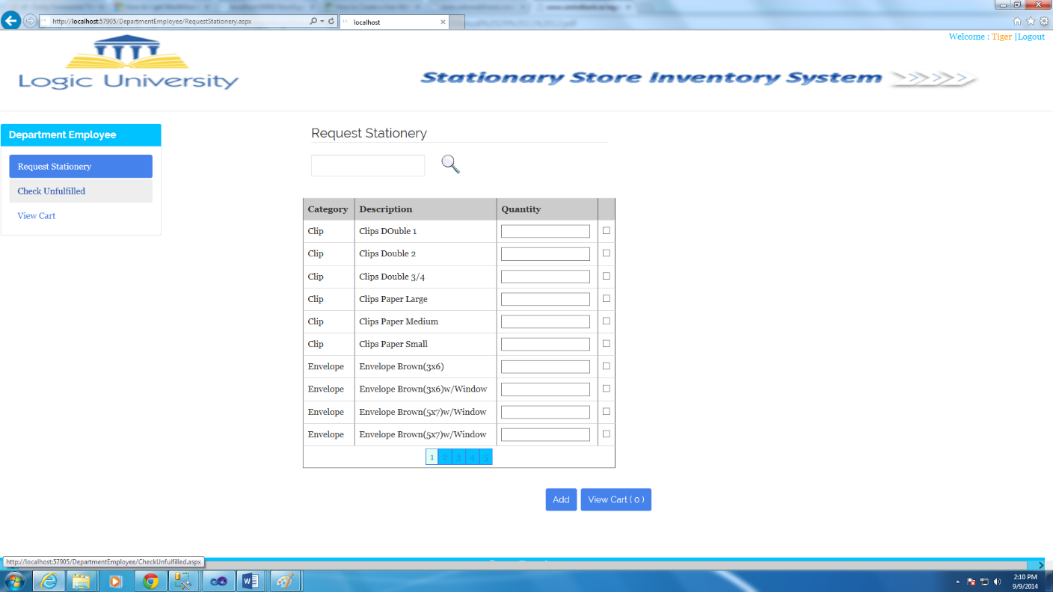

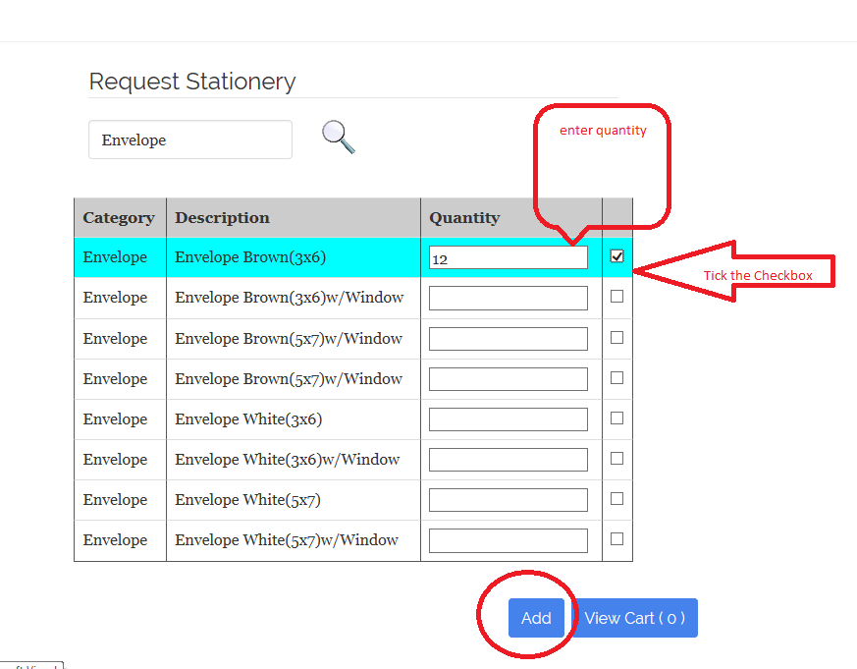

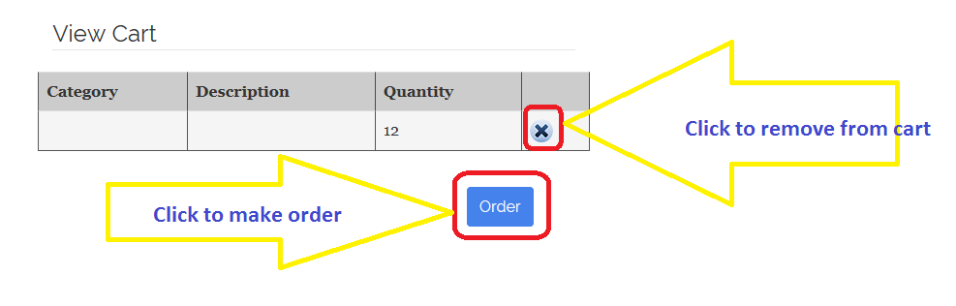

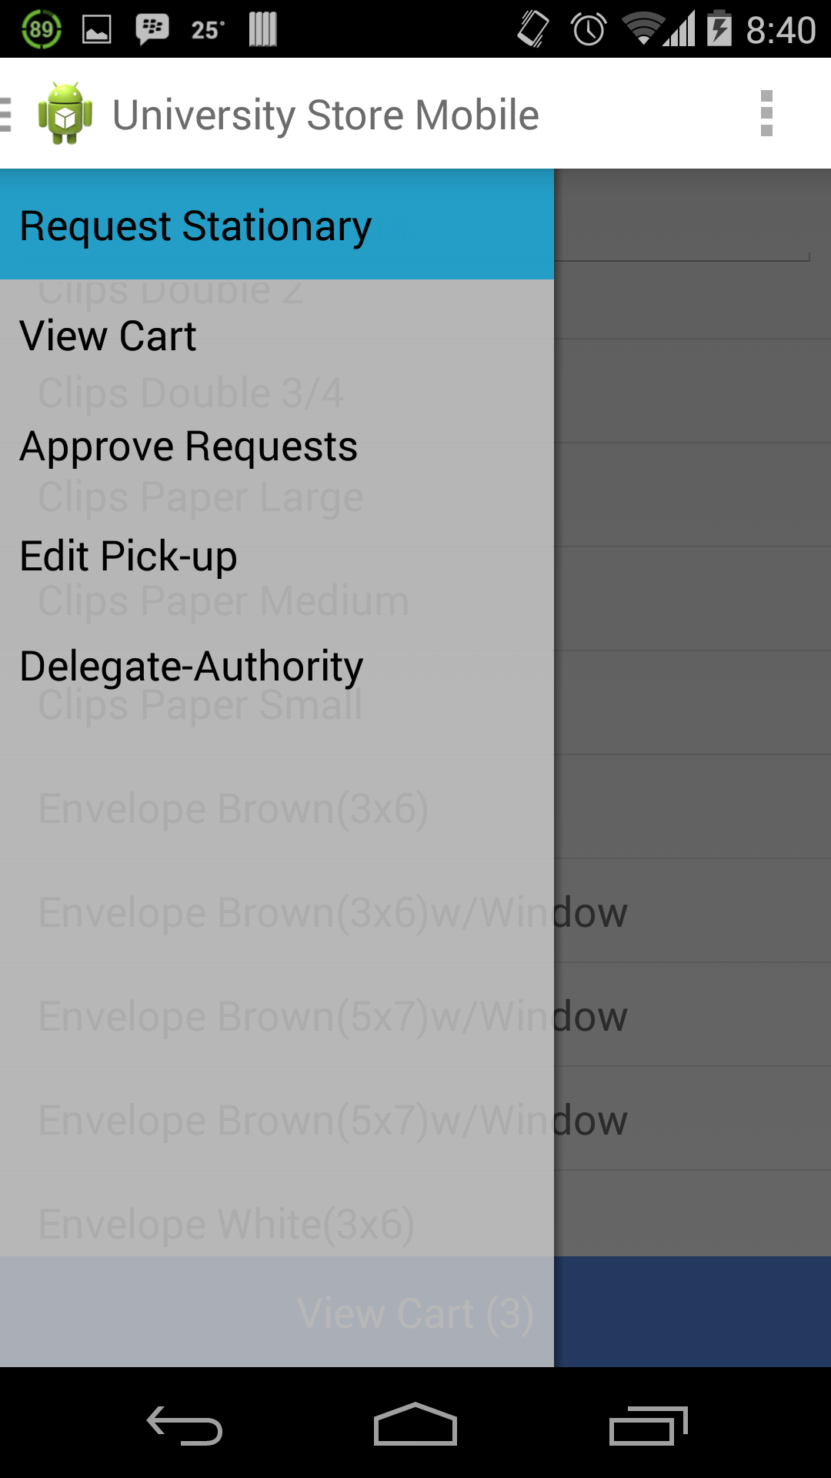

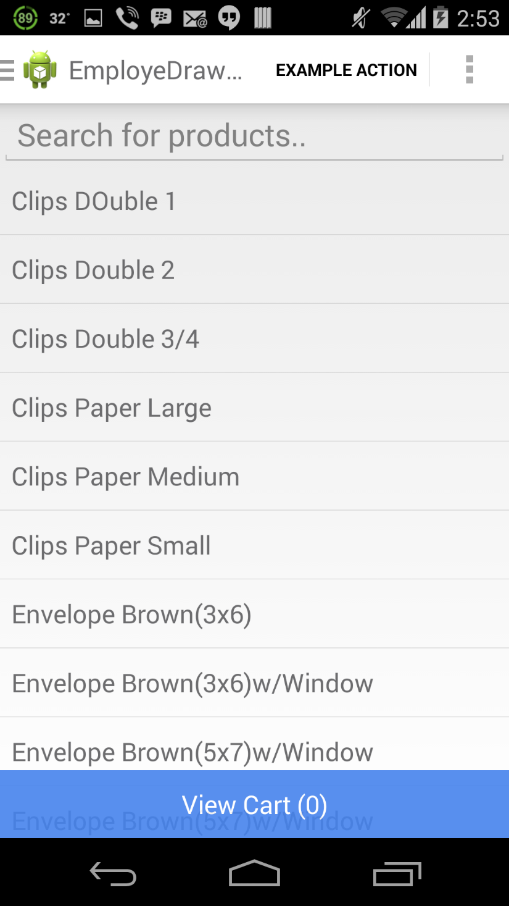

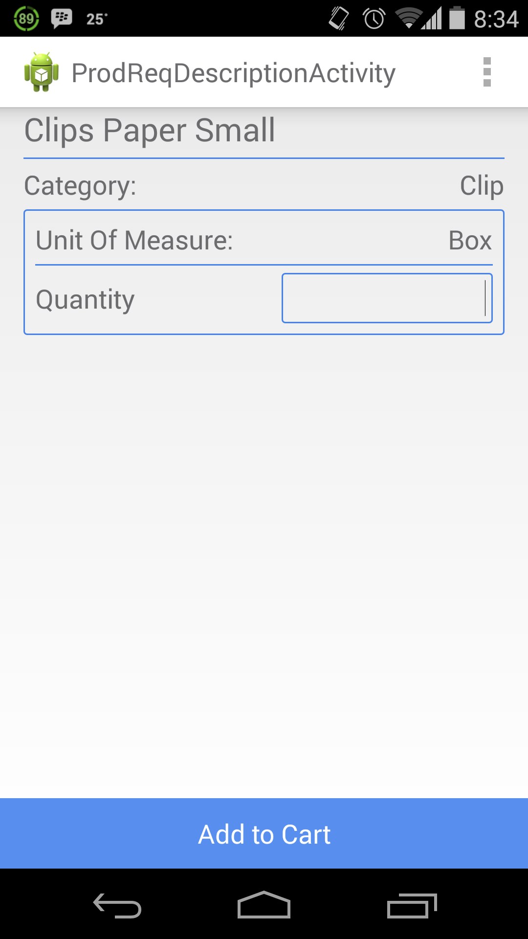

### Approve Request

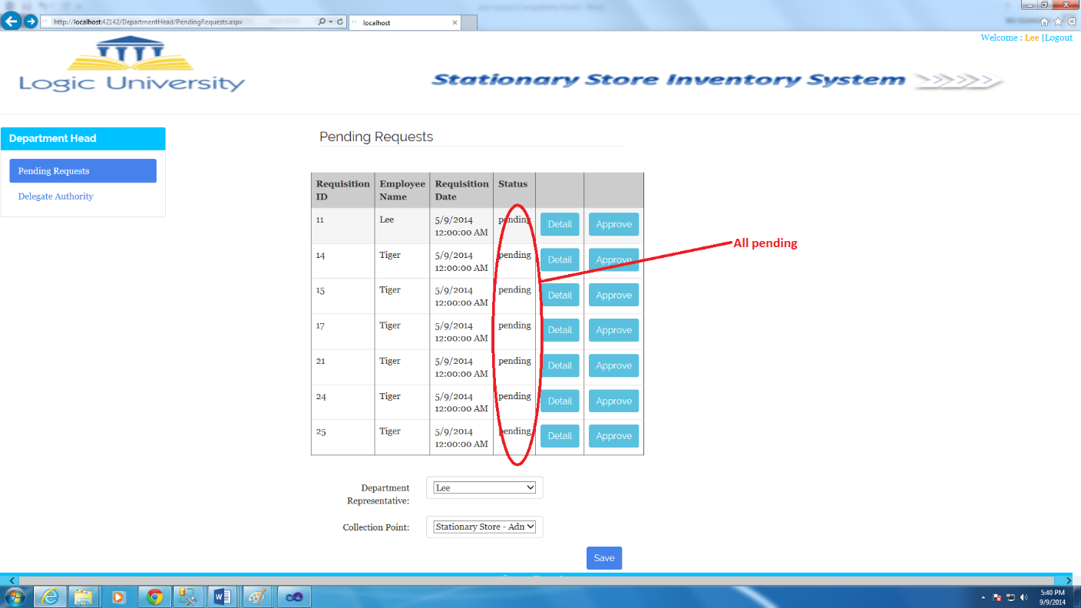

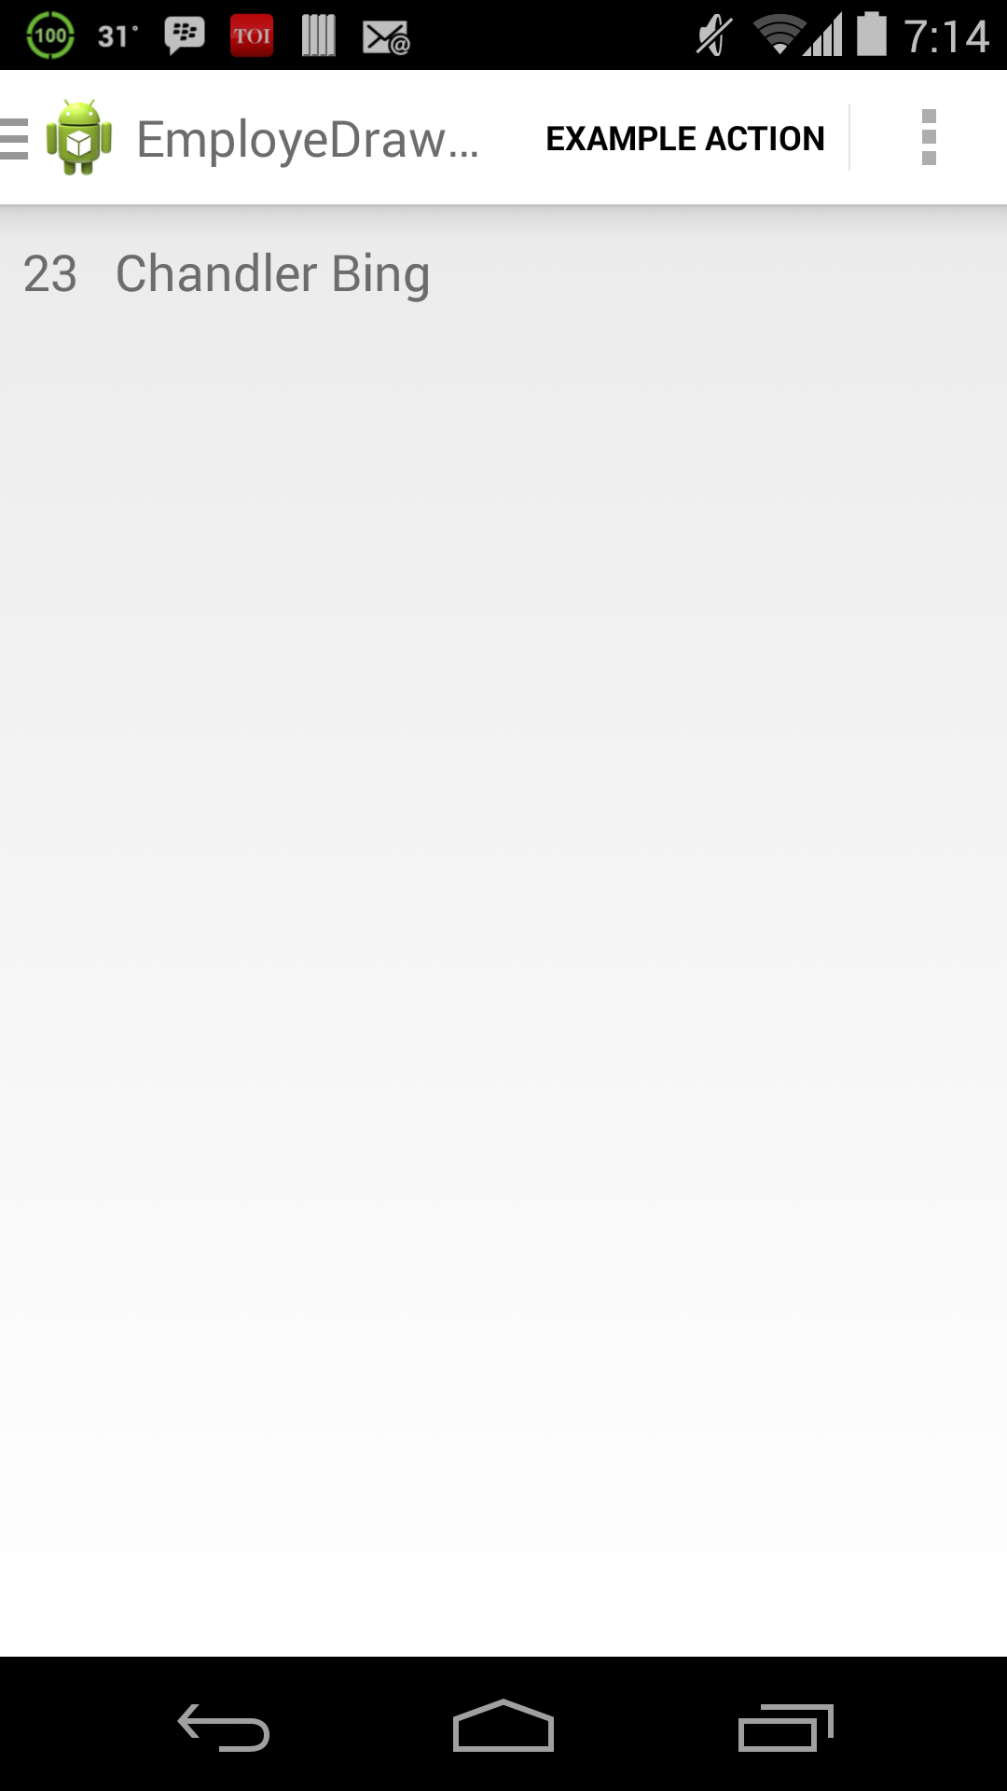

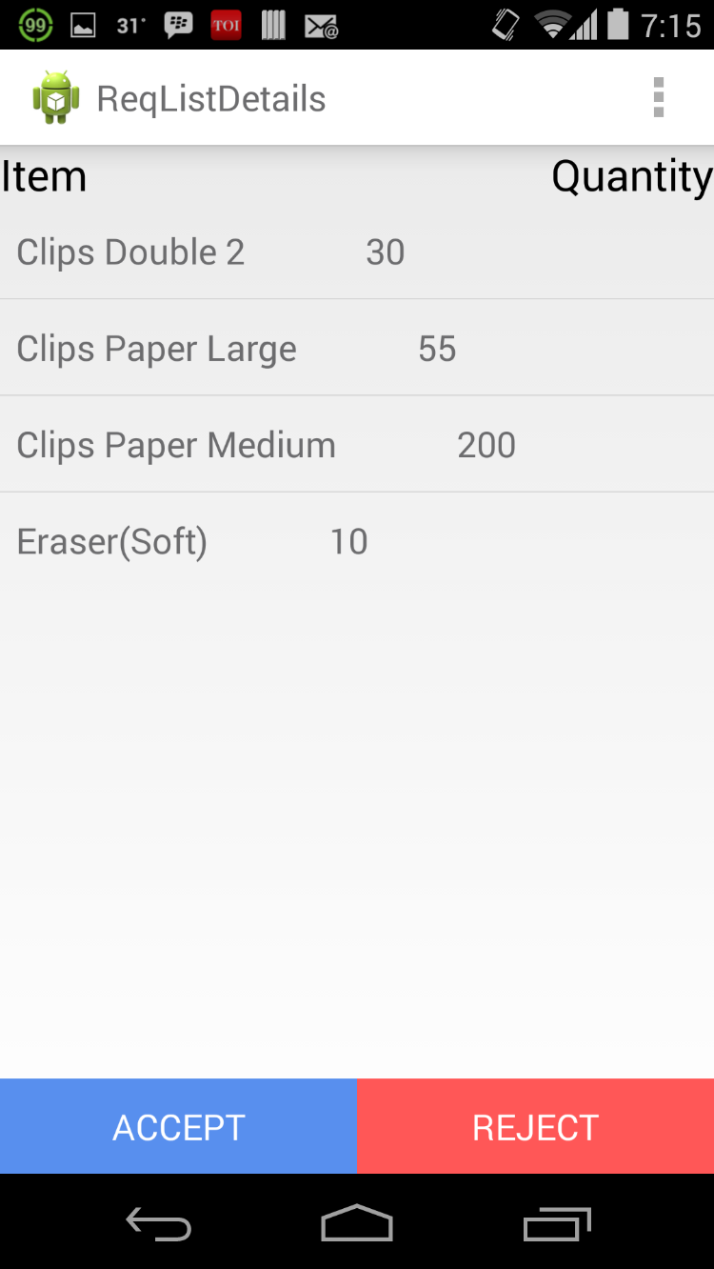

### Edit Pick-up

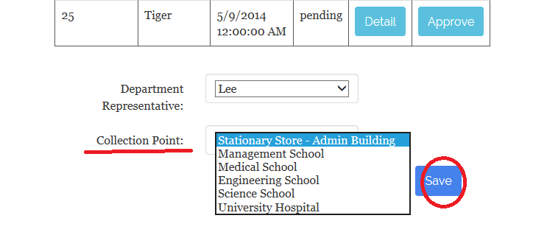

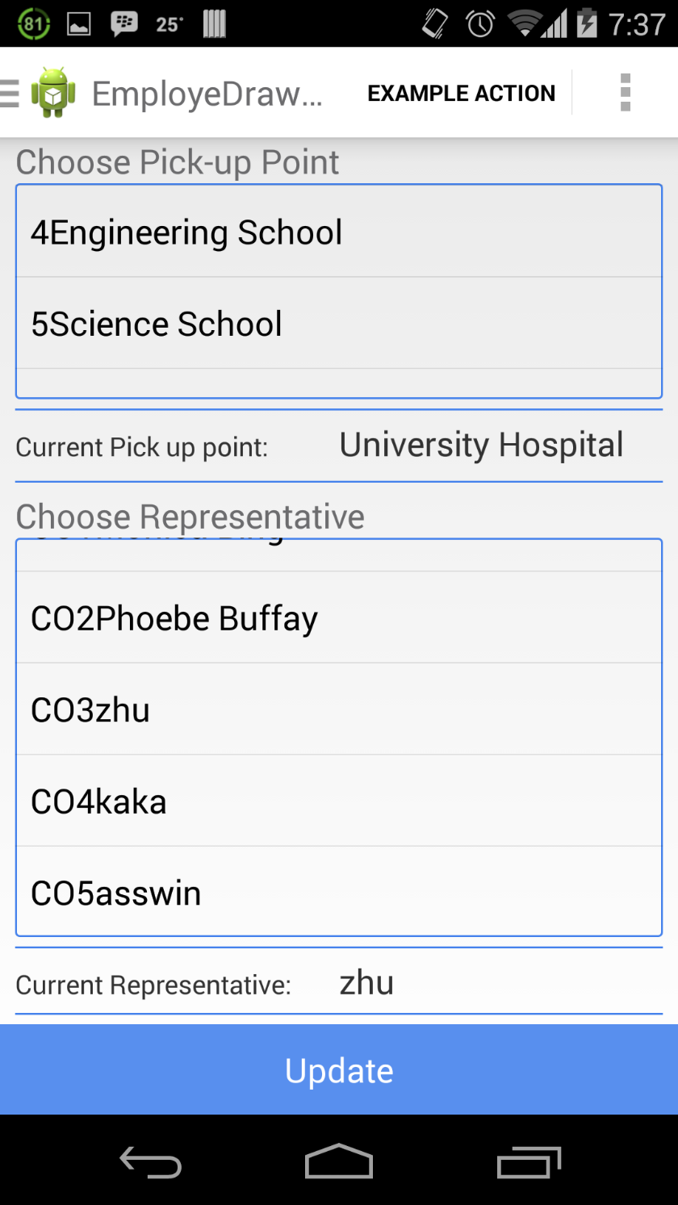

### Delegate Authority

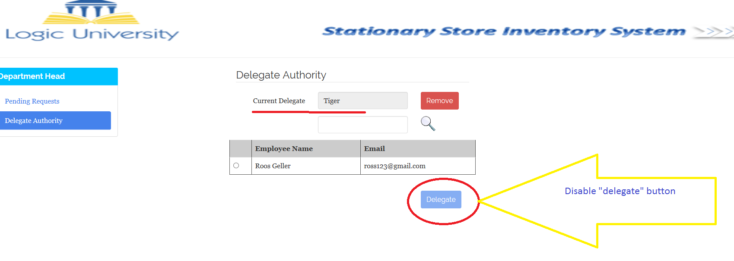

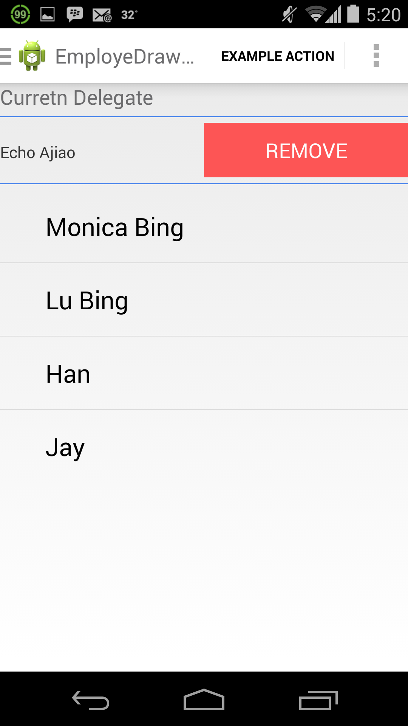

### View requisition

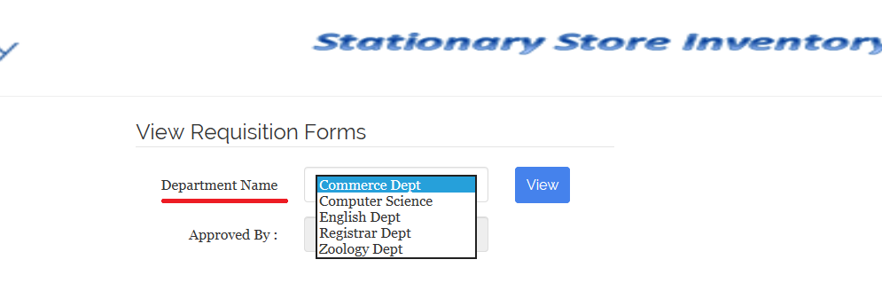

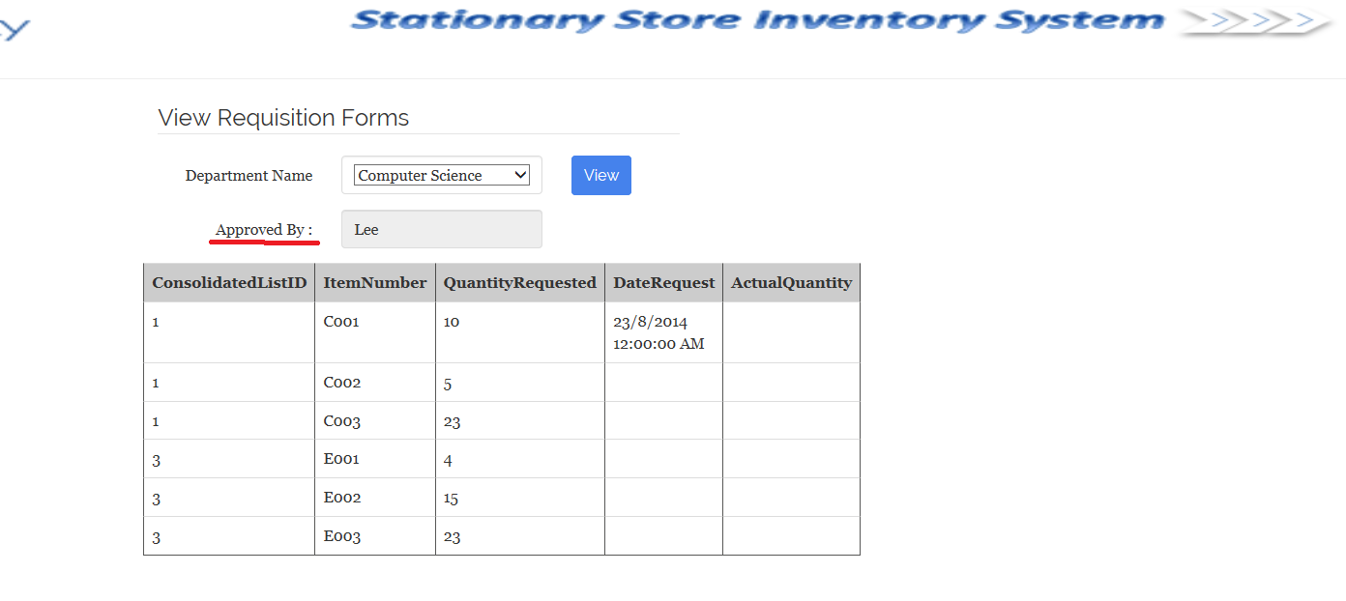

### Raise purchase order

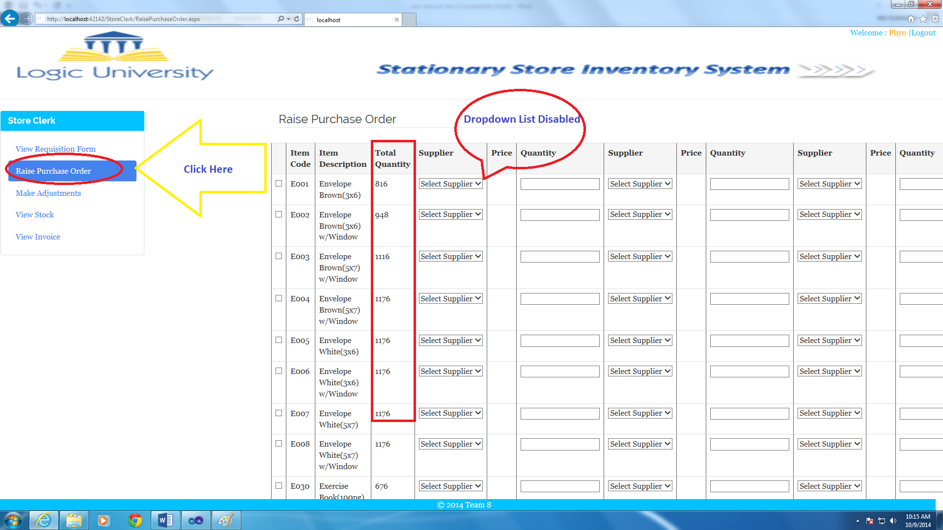

### View stock

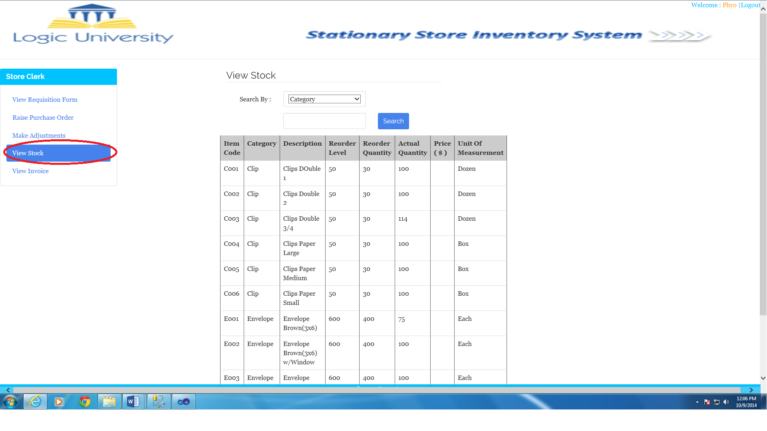

### Accept supply

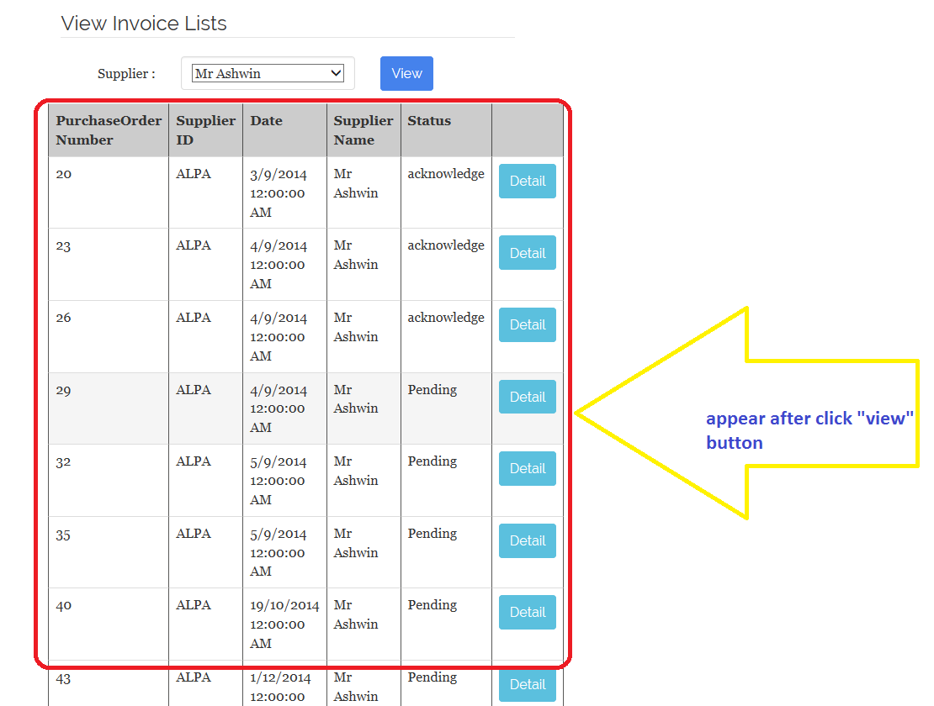

### Issue adjustment voucher

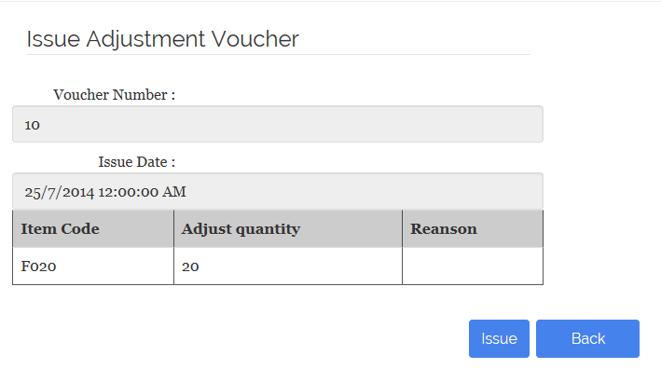

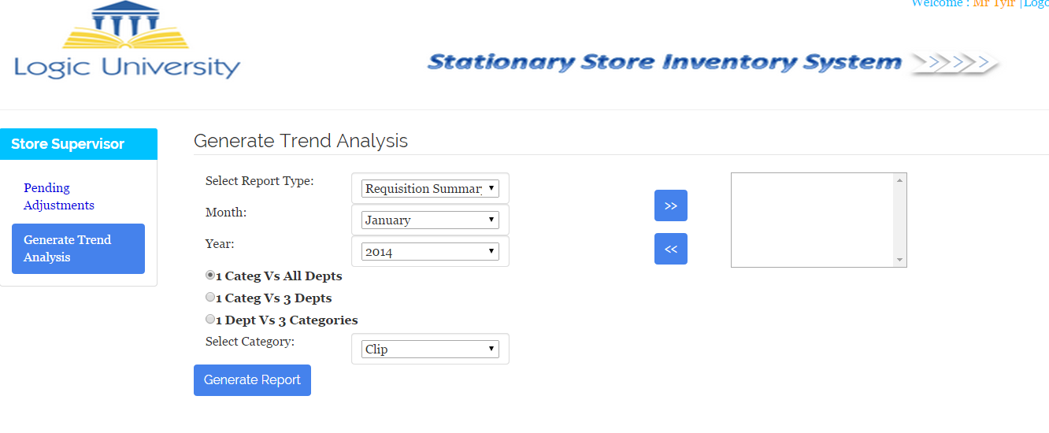

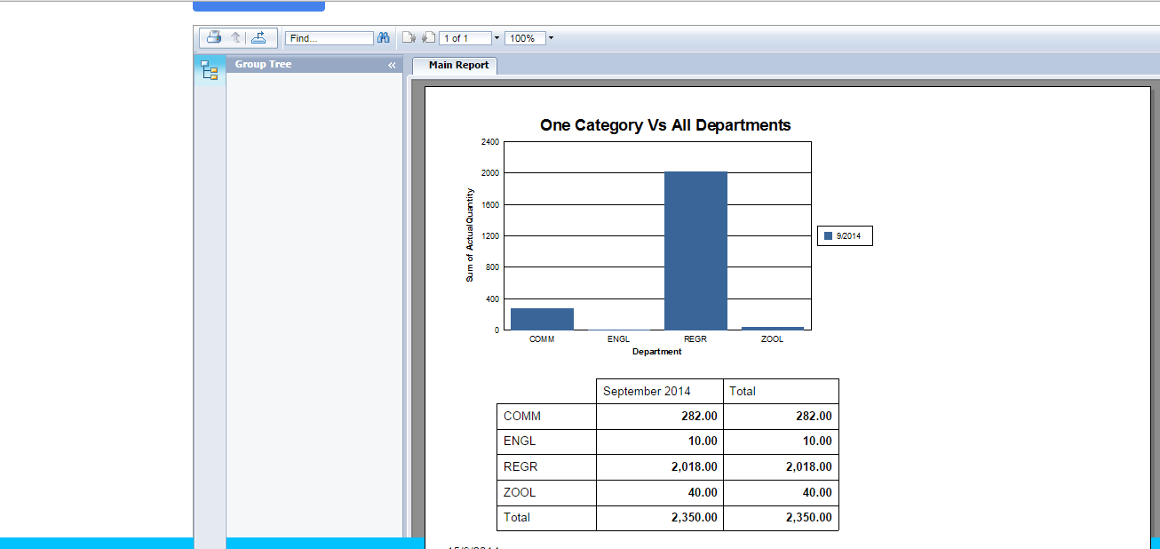

### Make adjustment

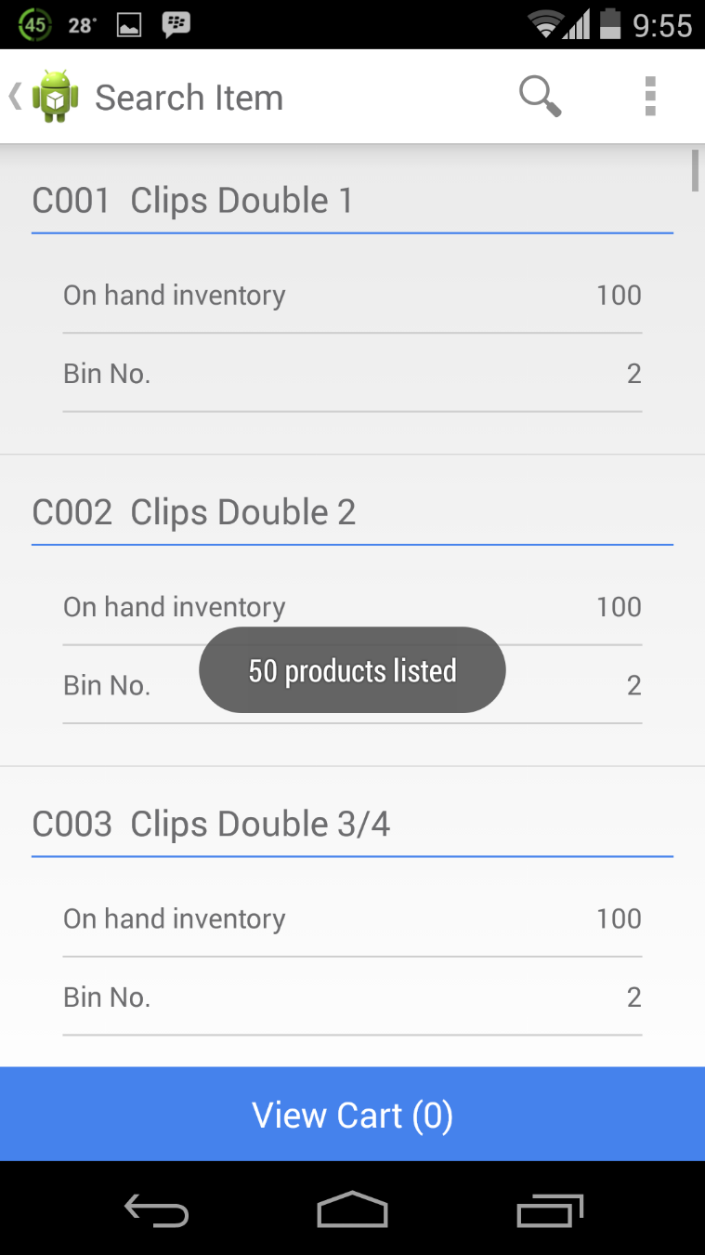

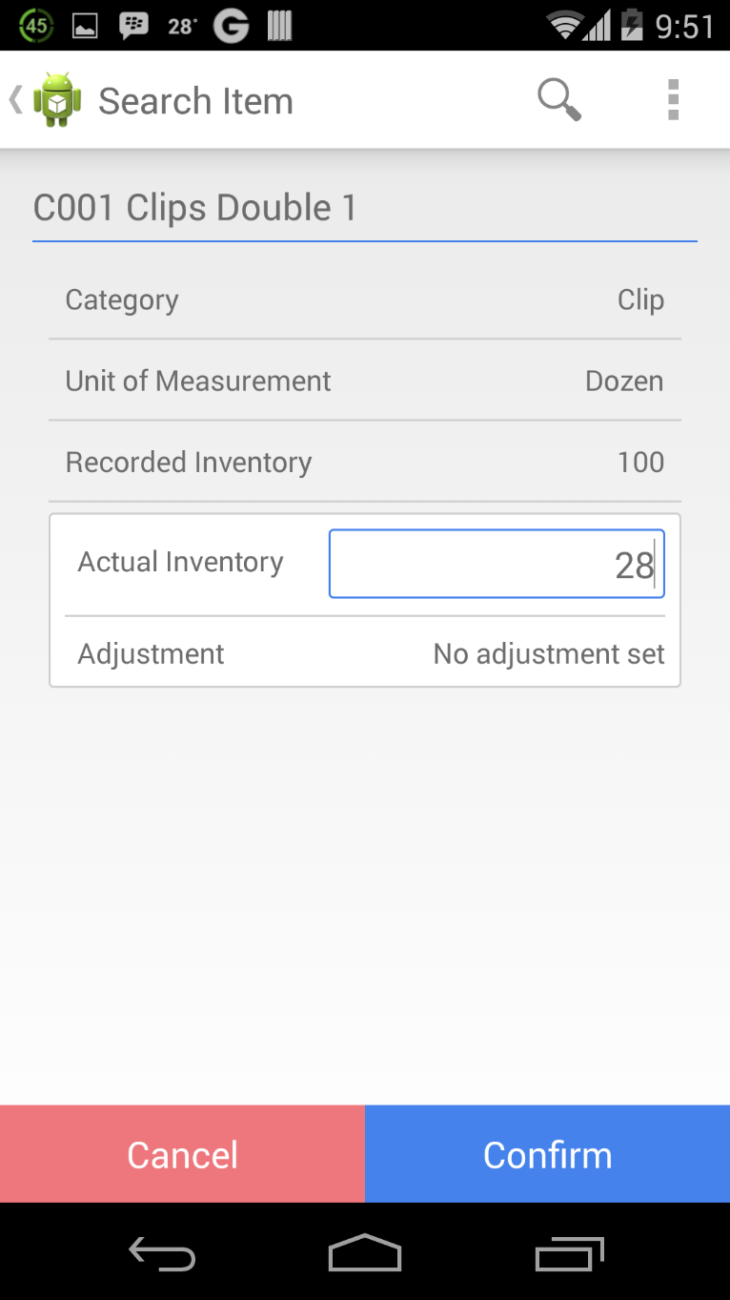

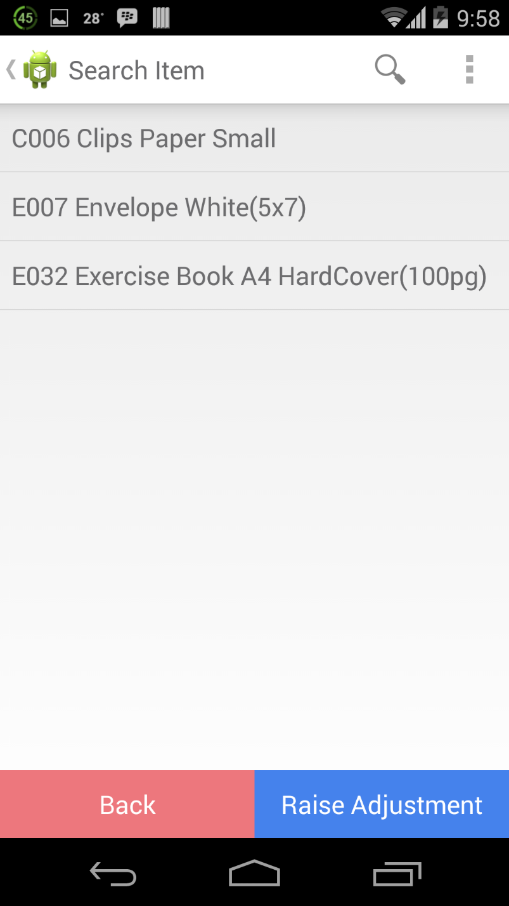

### Deliver Request

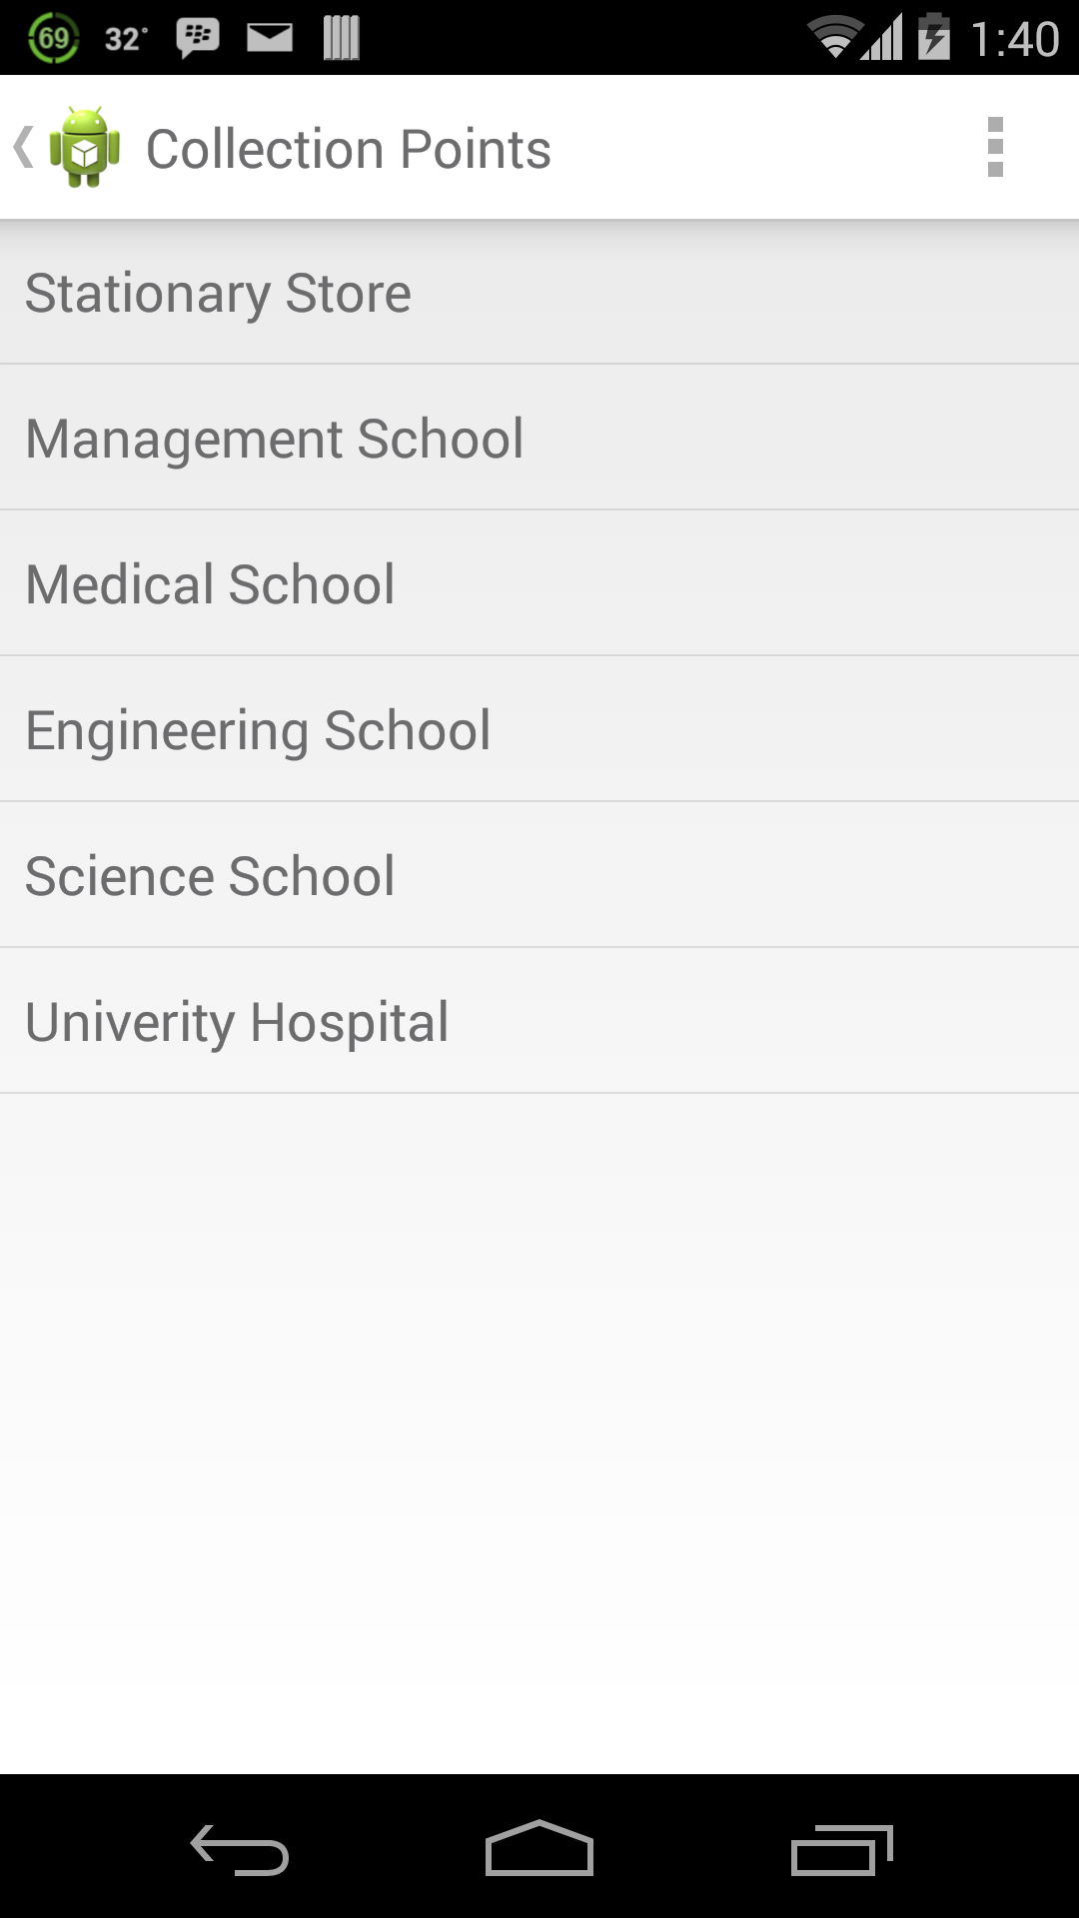

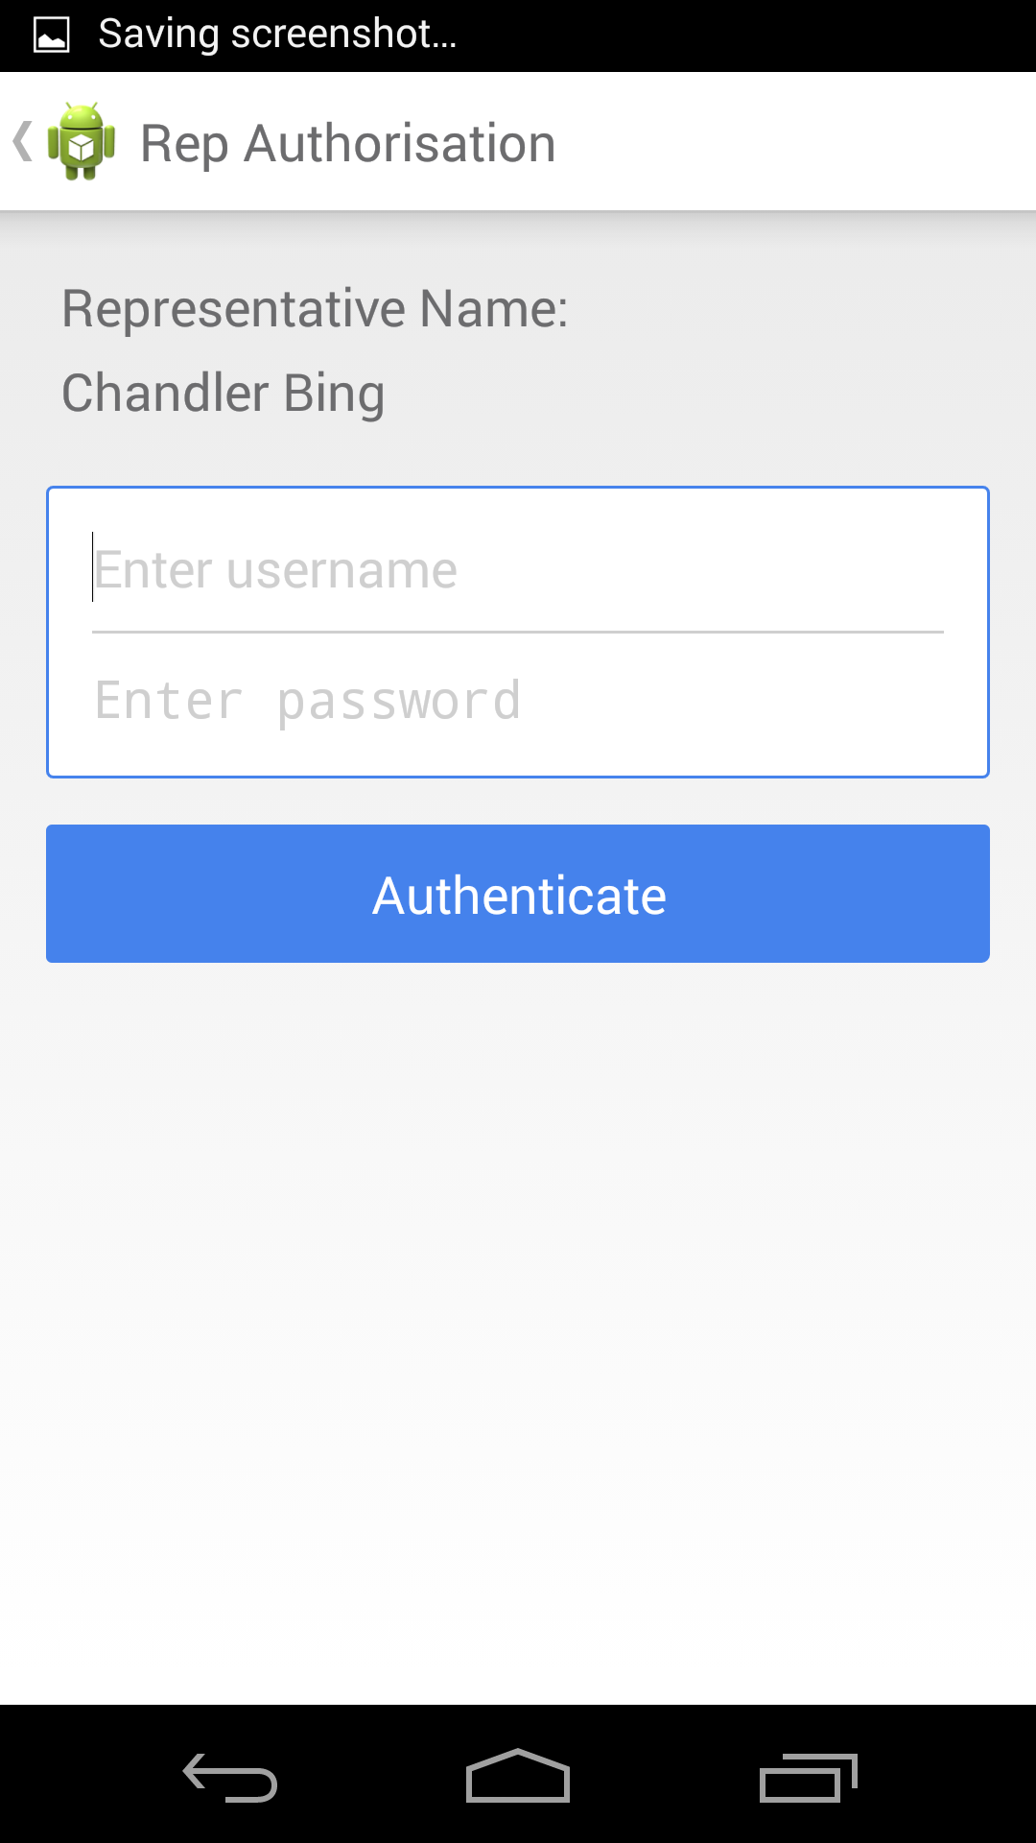

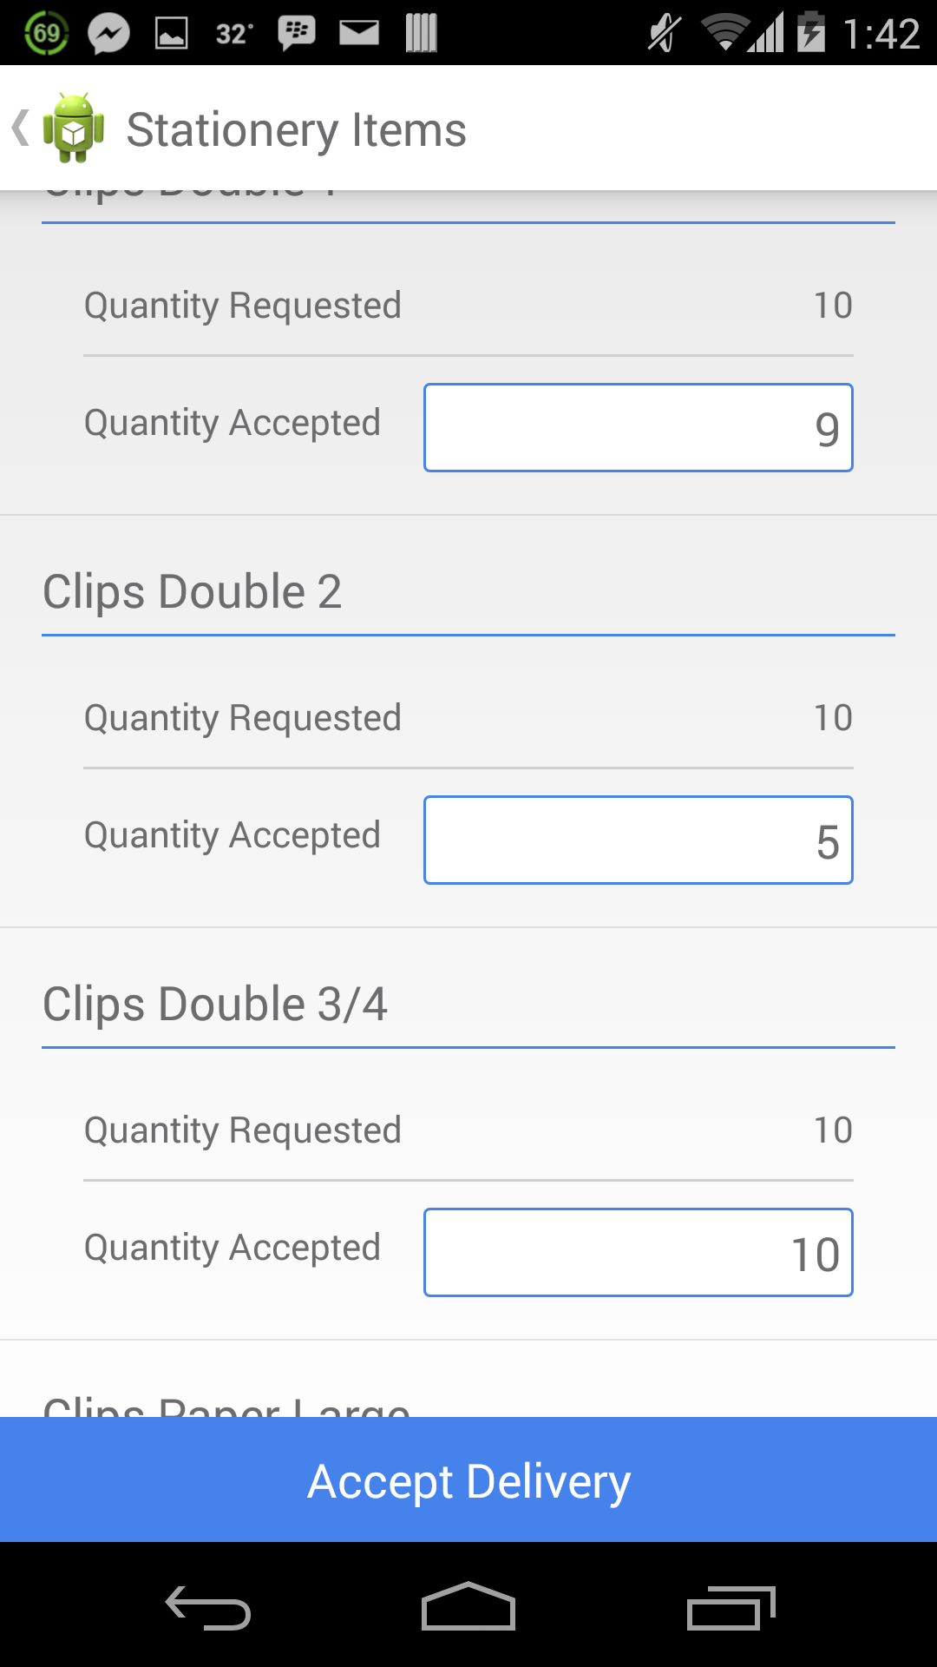

### Collect Stationary

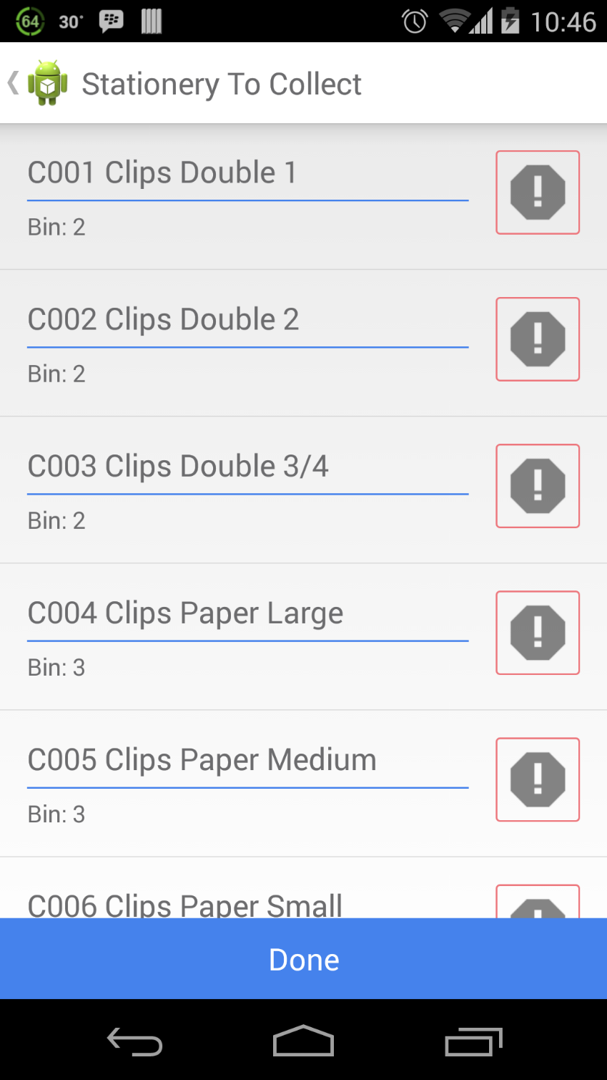

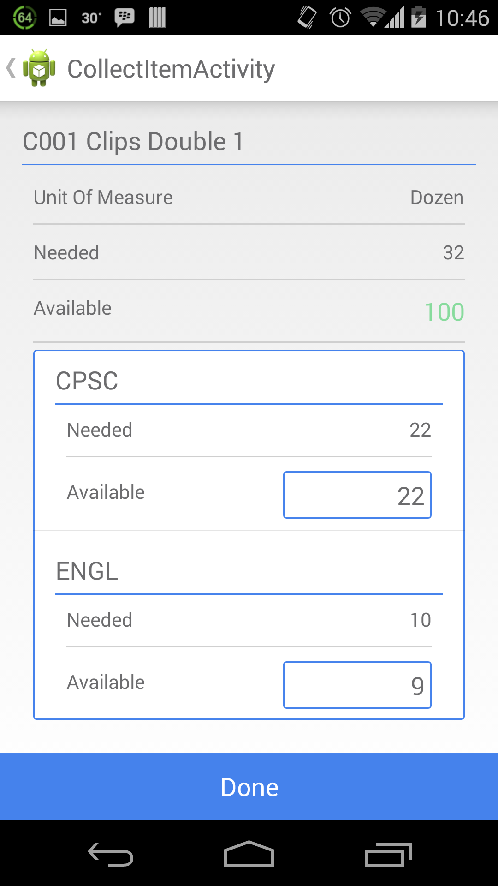

## State chart

### RAISE PURCHASE ORDER UI

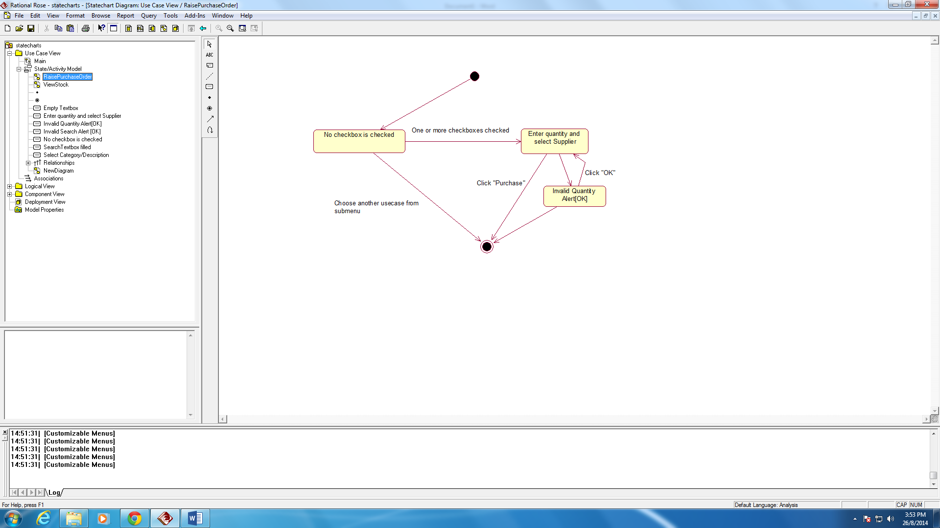

### VIEW STOCK UI

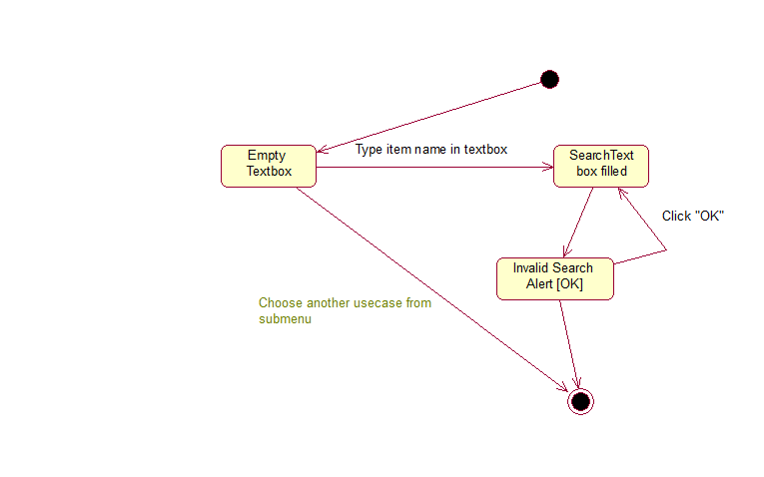

### DELEGATE AUTHORITY

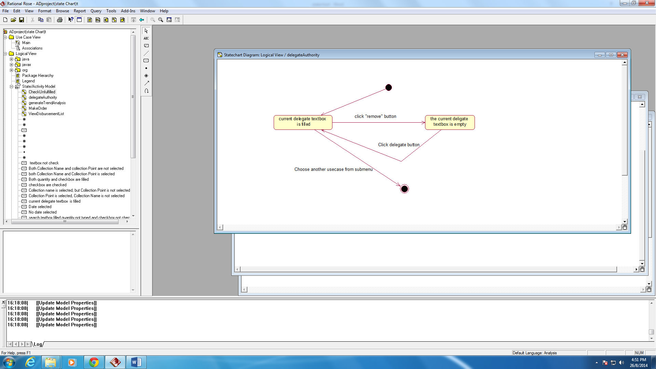

### REQUEST STATIONARY

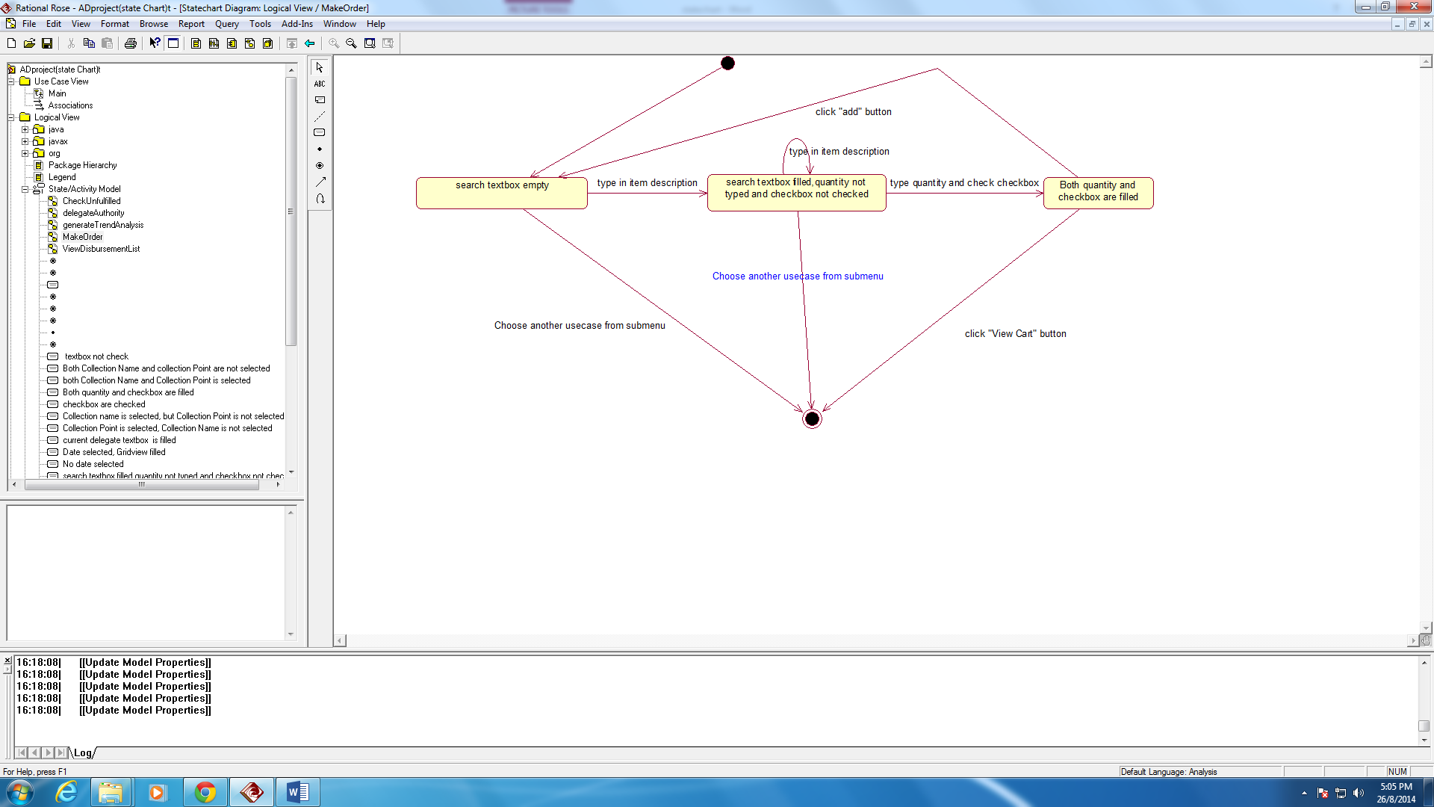

### VIEW DISBURSEMENT LIST

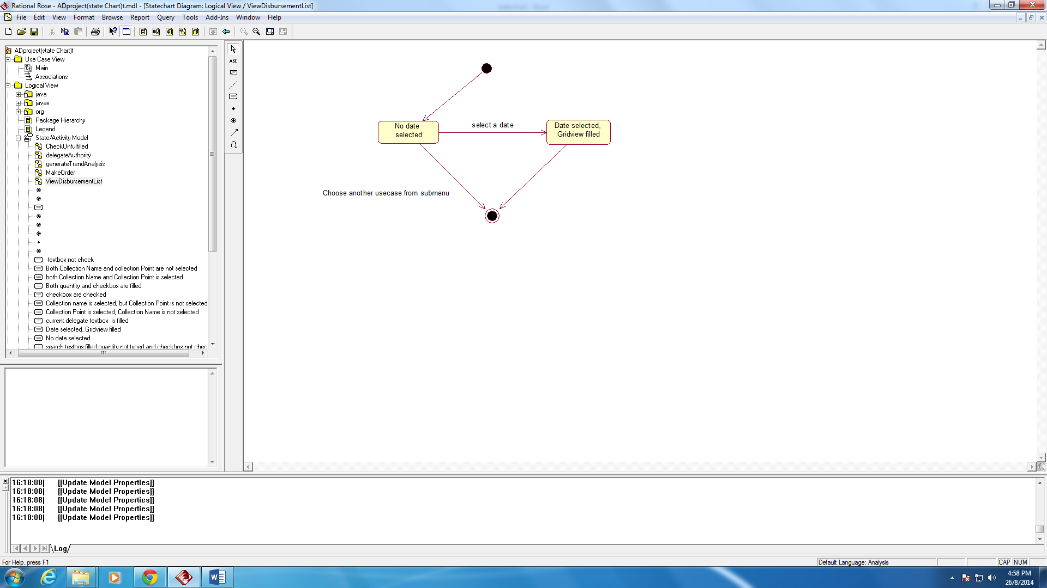

### Collect Stationary(Screen 12)



### Retrieval Form(Screen13)



### Change preference (Screen 7)

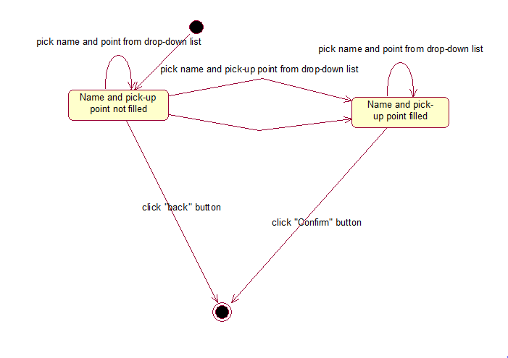

### Delegate authority

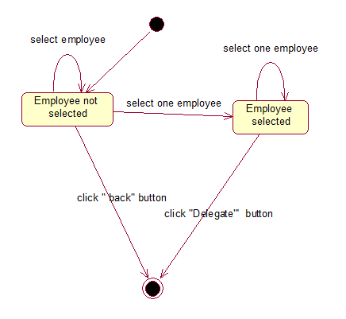

### Login

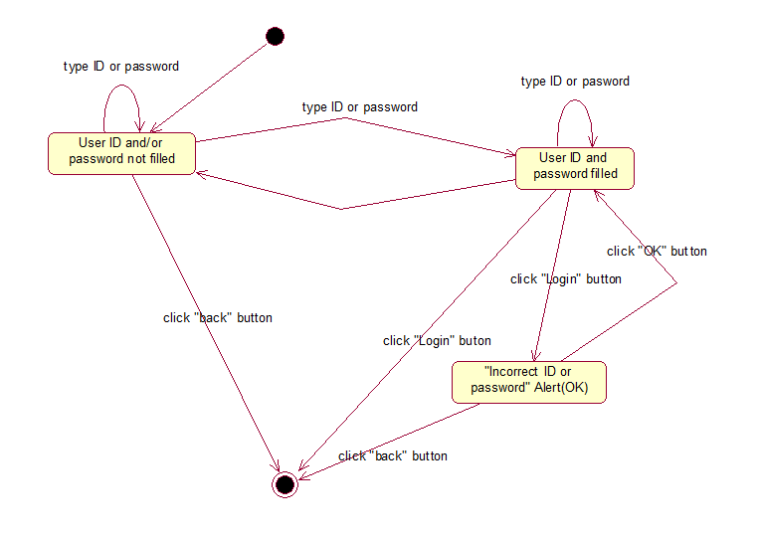

### Screen 4

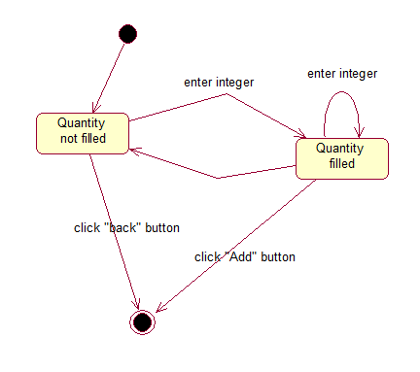

## Architectural Platform

**ARCHITECTURAL PLATFORM**

**WEB APPLICATION**

**Database**: Microsoft SQL Server 2008

**IDE**: Visual Studio 2010, SQL Server Management Studio

|  |  |
| --- | --- |
| **USE CASE** | **TECHNOLOGY USED AND DESIGN STRATEGY** |
| REQUEST STATIONARY | ASP.NET, ENTITY FRAMEWORK 4.0 |
| CHECK UNFULFILLED | ASP.NET, ENTITY FRAMEWORK 4.0 |
| DELEGATE AUTHORITY | ASP.NET, ENTITY FRAMEWORK 4.0 |
| EDIT PICKUP | ASP.NET, ENTITY FRAMEWORK 4.0 |
| APPROVE REQUESTS | ASP.NET, ENTITY FRAMEWORK 4.0 |
| GENERATE TREND | ASP.NET, CRYSTAL REPORTS, ADO.NET TABLE ADAPTER |
| ISSUE ADJUSTMENT VOUCHER | ASP.NET, ENTITY FRAMEWORK 4.0 |
| VIEW REQUISITION | ASP.NET, ENTITY FRAMEWORK 4.0 |
| RAISE PURCHASE ORDER | ASP.NET, ENTITY FRAMEWORK 4.0 |
| VIEW STOCK | ASP.NET, ENTITY FRAMEWORK 4.0 |
| ACCEPT SUPPLY | ASP.NET, ENTITY FRAMEWORK 4.0 |
| DELIVER REQUEST | ASP.NET, ENTITY FRAMEWORK 4.0 |
| ALERT LOW STOCK | ASP.NET, ENTITY FRAMEWORK 4.0 |

**MOBILE APPLICATION**

**Database:** Microsoft SQL Server 2008

**IDE**: Eclipse, Visual Studio 2010, SQL Server Management Studio

|  |  |
| --- | --- |
| **USE CASE** | **TECHNOLOGY USED AND DESIGN STRATEGY** |
| COLLECT STATIONARY | ANDROID, WCF |
| DELIVER REQUEST | ANDROID,WCF |
| MAKE ADJUSTMENT | ANDROID,WCF |
| ACCEPT SUPPLY | ANDROID,WCF |
| REQUEST STATIONARY | ANDROID,WCF |
| DELIGATE AUTHORITY | ANDROID,WCF |
| APPROVE REQUESTS | ANDROID,WCF |
| EDIT PICKUP | ANDROID,WCF |

**SYSTEM ARCHITECTURE**

**USERS**



DEPT HEAD

STORE SUPERVISOR

STORE CLERK

DEPT EMPLOYEE

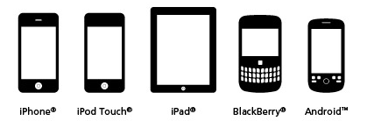

WEB APPLICATION MOBILE APPLICATION

**PRESENTATION TIER**



IIS/ASP.NET, Crystal Reports, WCF, CSS, javascript, jquery, Entity Framework, Datasets,

**WEB SERVER**

**BUSINESS LOGIC TIER**



**DATABASE SERVER** SQL SERVER Management

Studio 200 R2

**DATA TIER**

## Final Design Sequence Diagram

WEB

### LOGIN

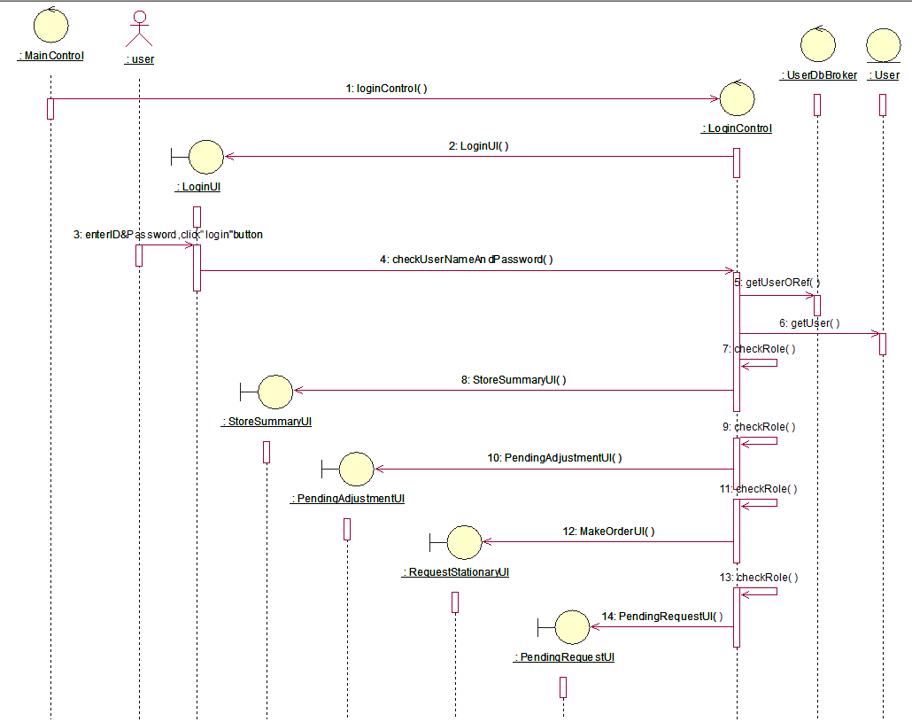

### D:\ADFinalProj\Updated seq\Screenshots\ApproveReq.PNGAPPROVE REQUEST

### ALERT LOW STOCK

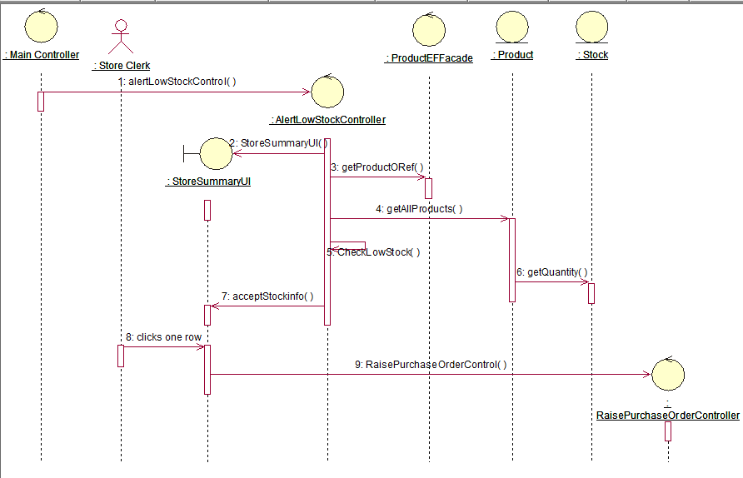

### CHECK UNFULFILLED

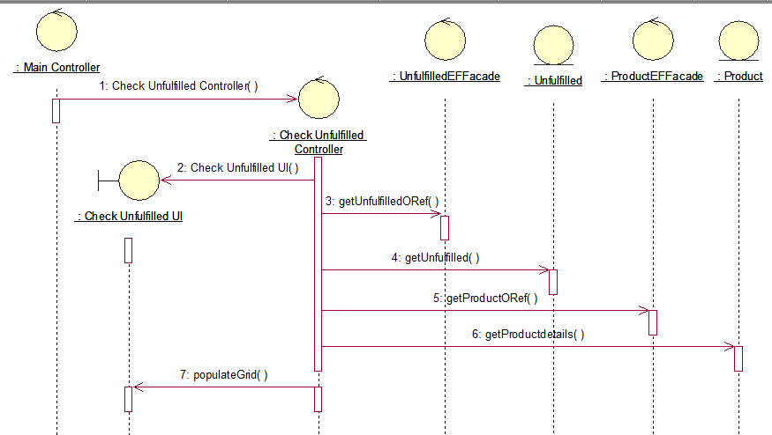

### RAISE PURCHASE ORDER

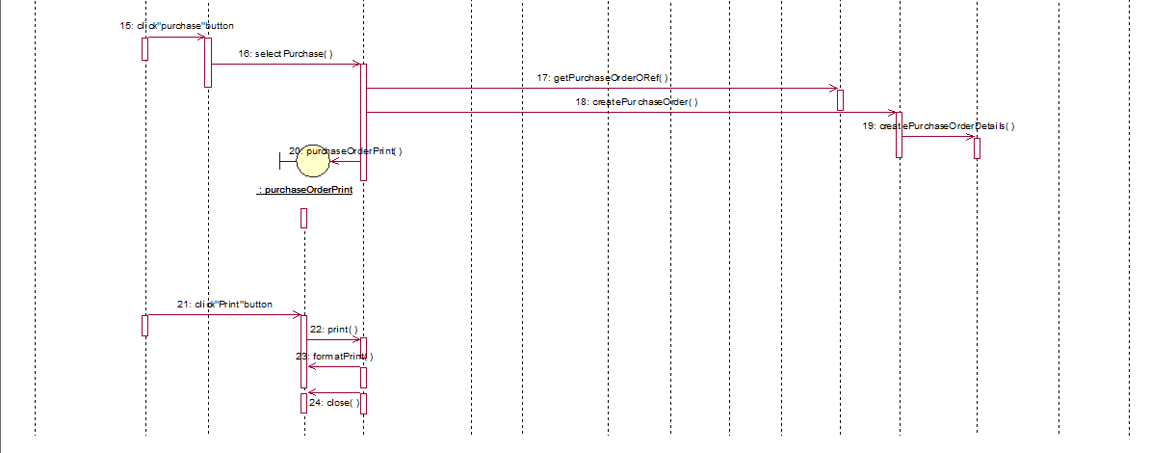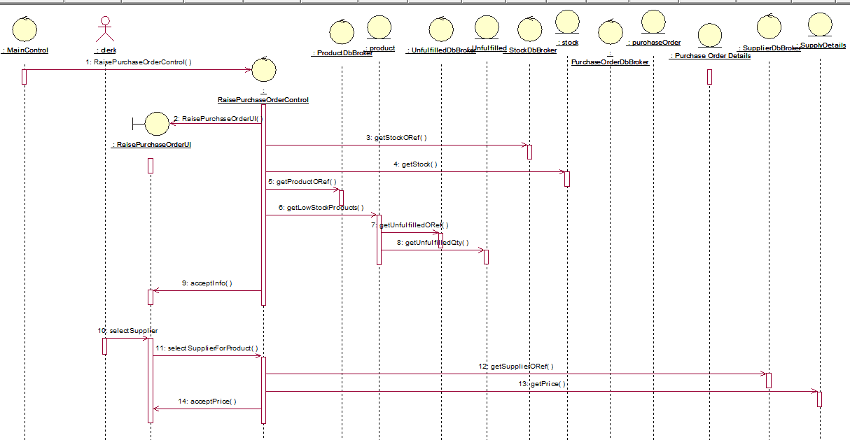

### ISSUE ADJUSTMENT VOUCHER

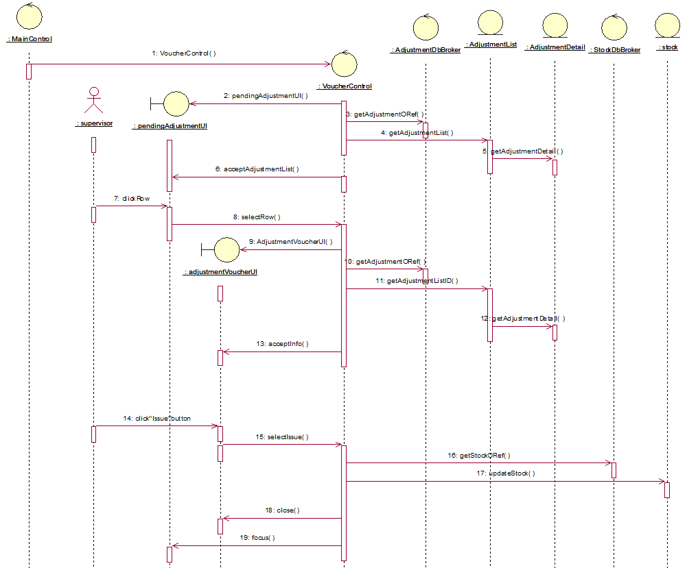

### D:\ADFinalProj\Updated seq\Screenshots\DelegateAuthority.PNGDELEGATE AUTHORITY

### EDIT PICKUP

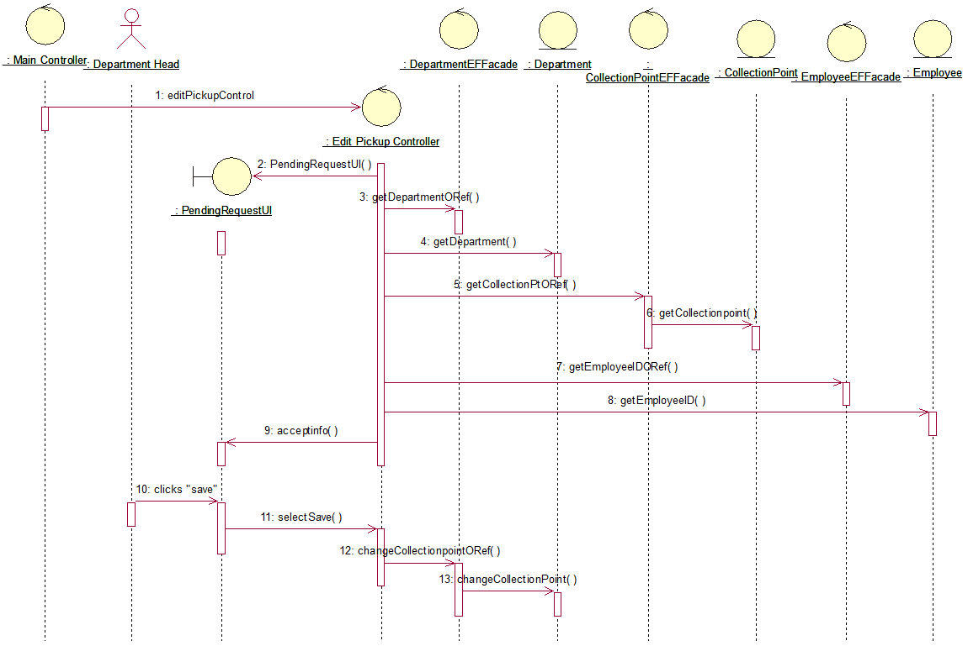

### D:\ADFinalProj\Updated seq\Screenshots\GT2.PNGD:\ADFinalProj\Updated seq\Screenshots\GT1.PNGGENERATE TREND ANALYSIS

### VIEW REQUSITION

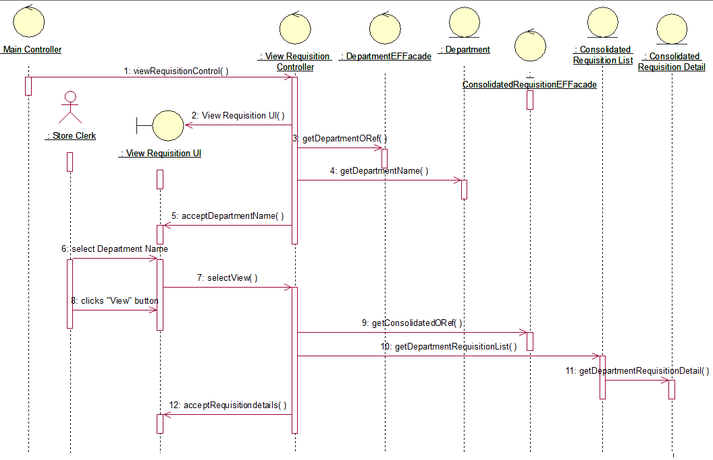

### D:\ADFinalProj\Updated seq\Screenshots\ViewStock.PNGVIEW STOCK

MOBILE

### APPROVE REQUEST

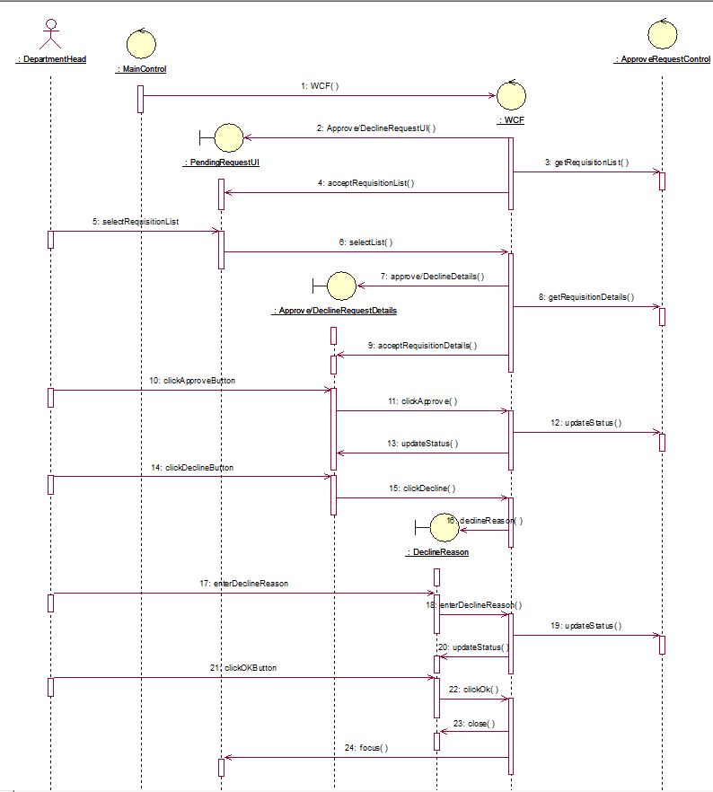

### DELEGATE AUTHORITY

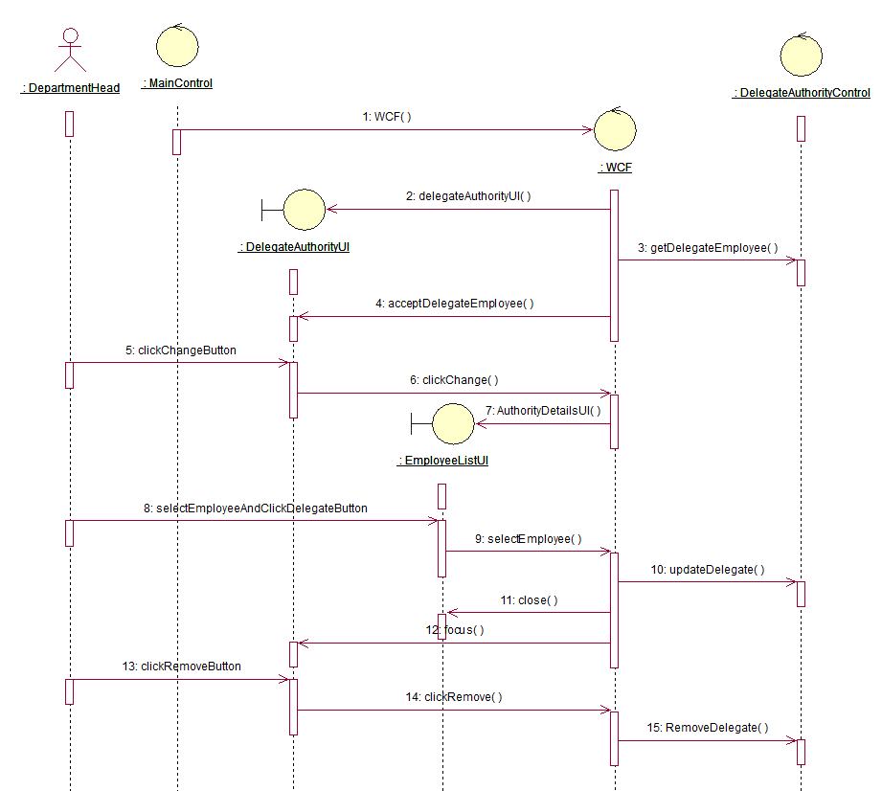

### DELIVER REQUEST

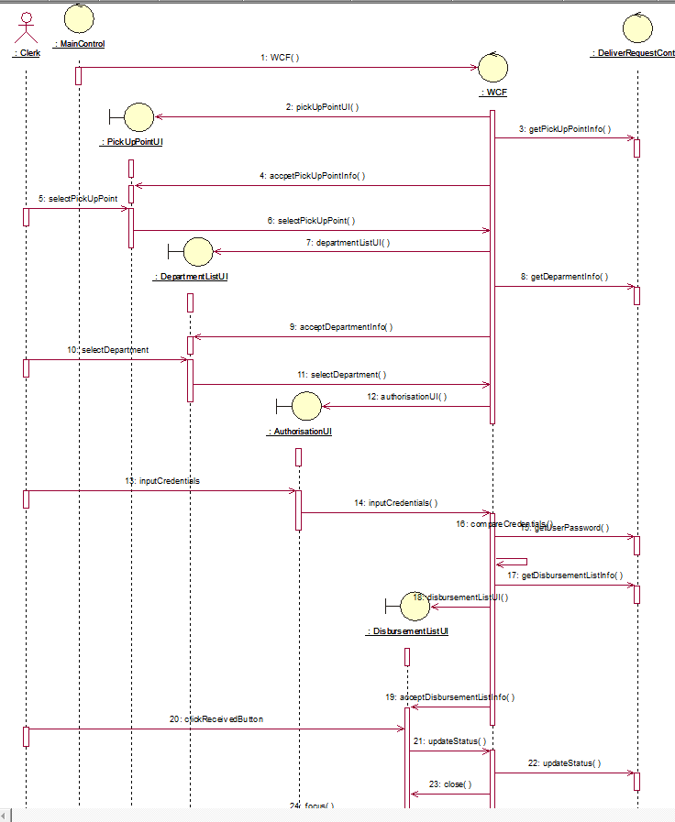

### EDIT PICK UP

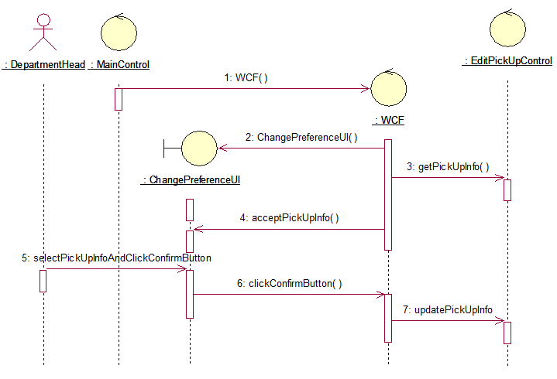

### ISSUE ADJUSTMENT VOUCHER

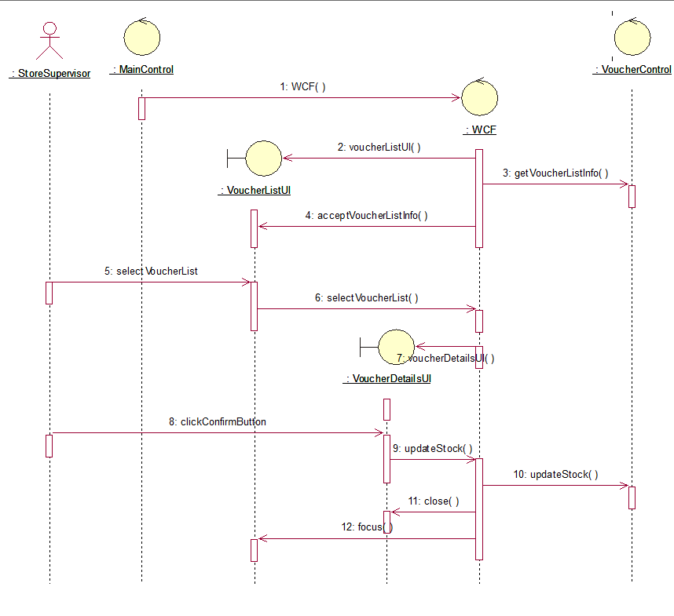

### REQUEST STATIONARY

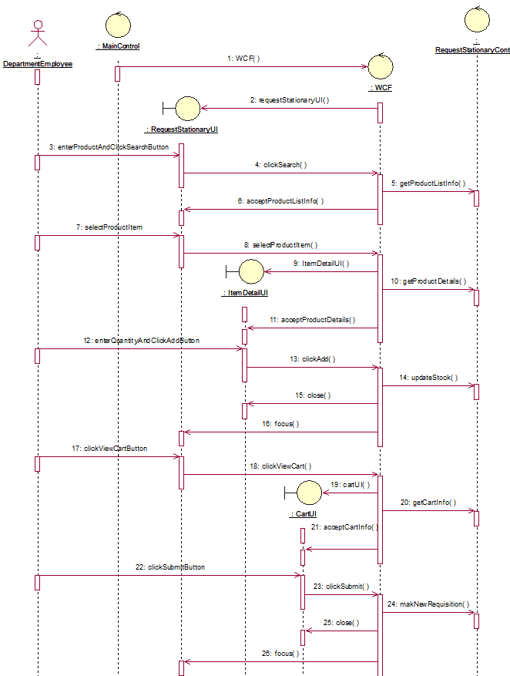

### ACCEPT SUPPLY

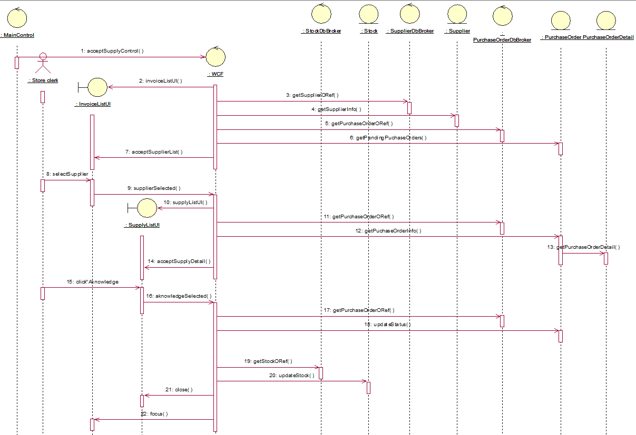

### MAKE ADJUSTMENT

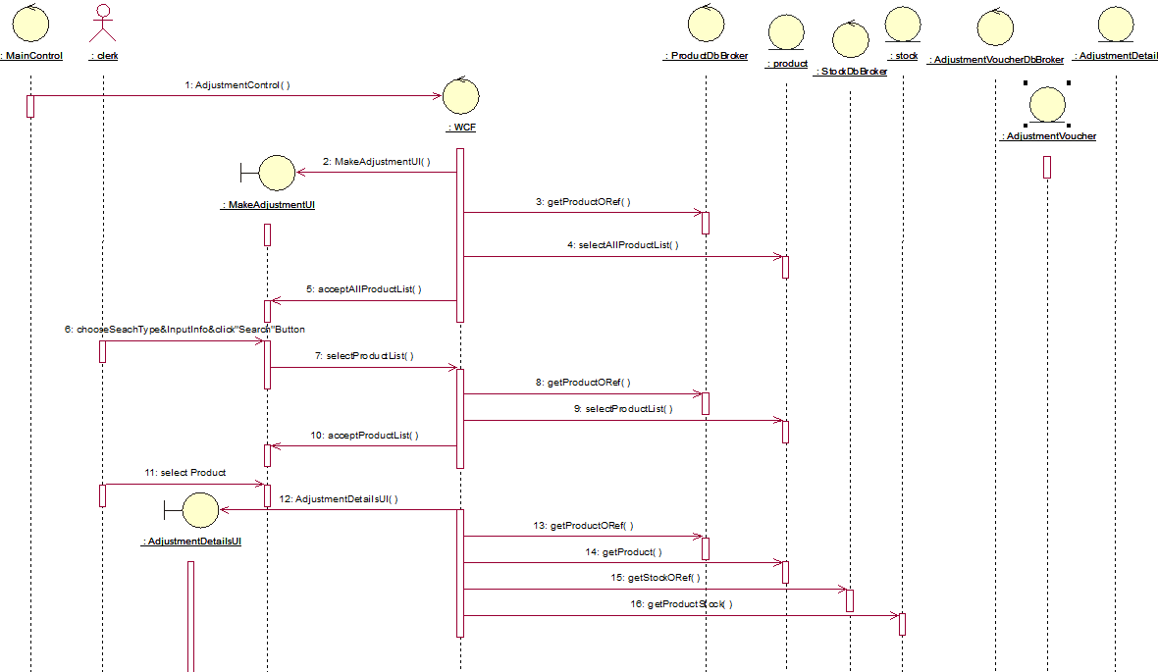

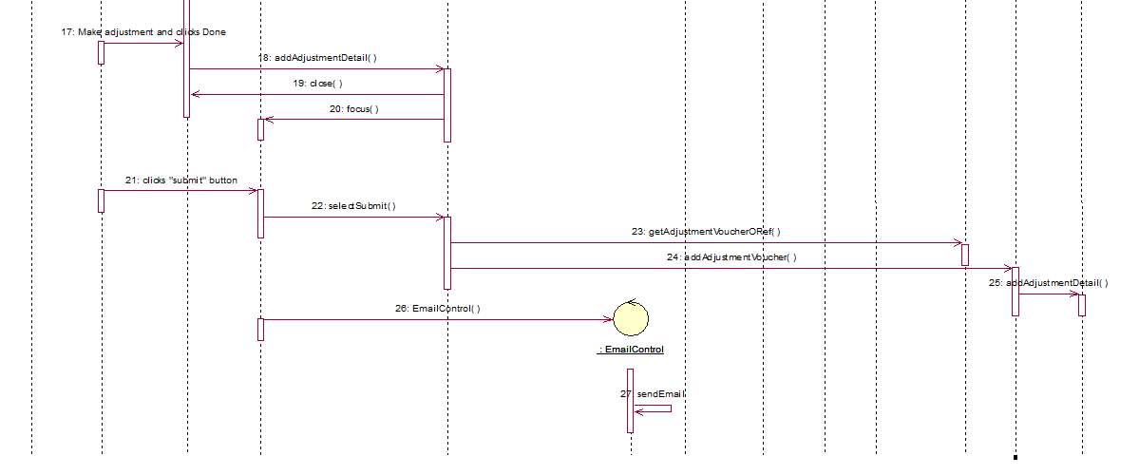

REFERENCES

COLLECT STATIONARY --- Refer file adproj_seqdiag.mdl

DELIVER REQUEST --- Refer file se23.mdl

## CONSOLIDATED CLASS DIAGRAM

### UI CLASS DIAGRAM

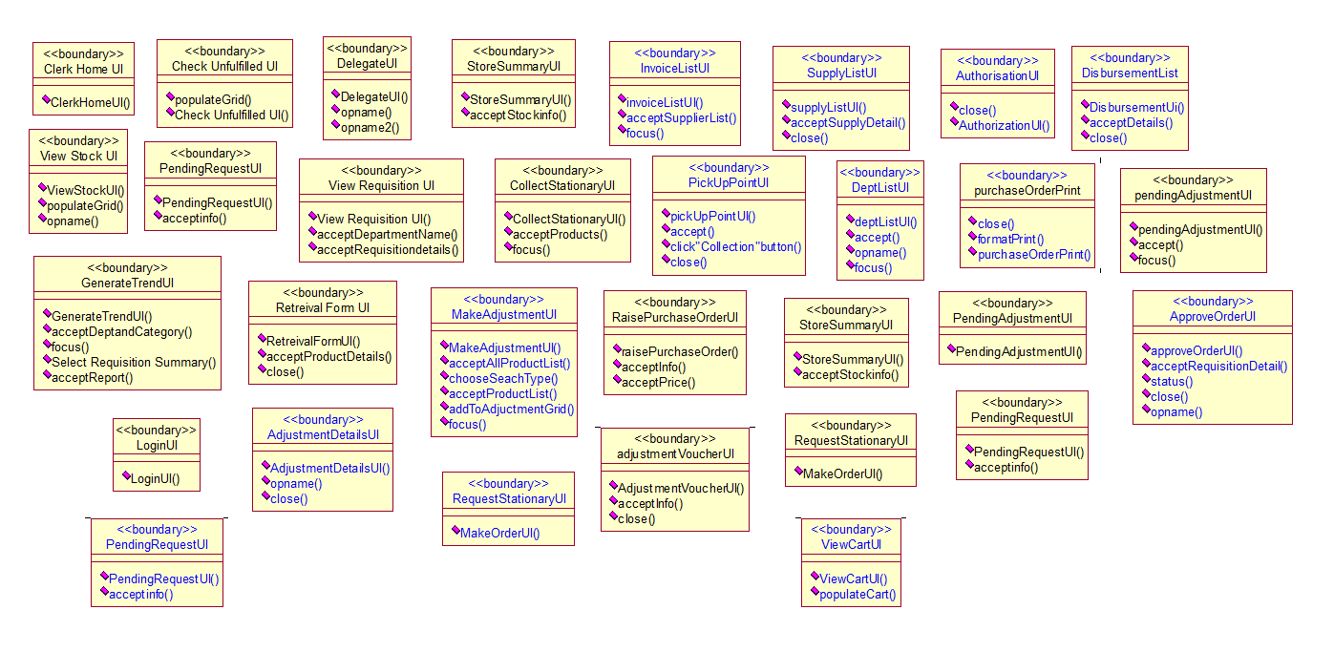

### CONTROL CLASS DIAGRAM

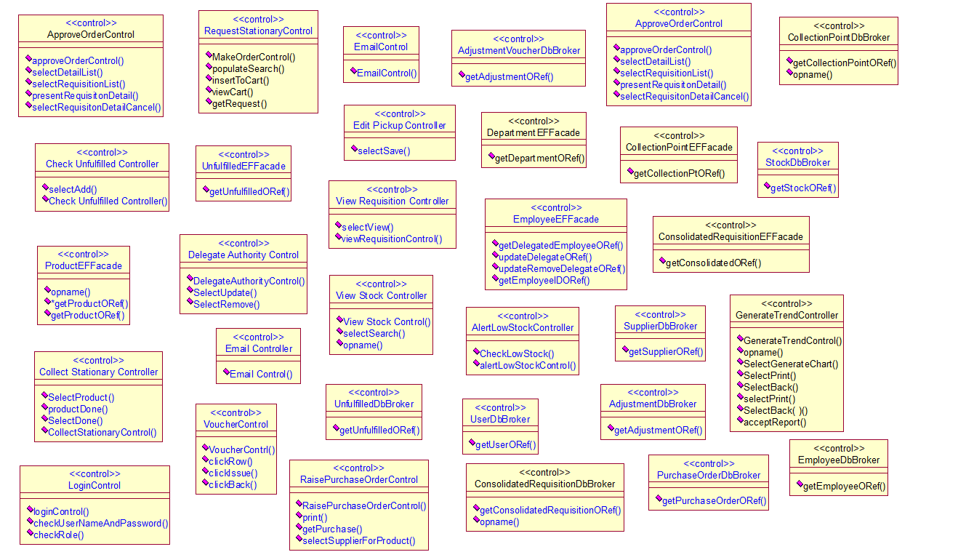

### ENTITY CLASS DIAGRAM

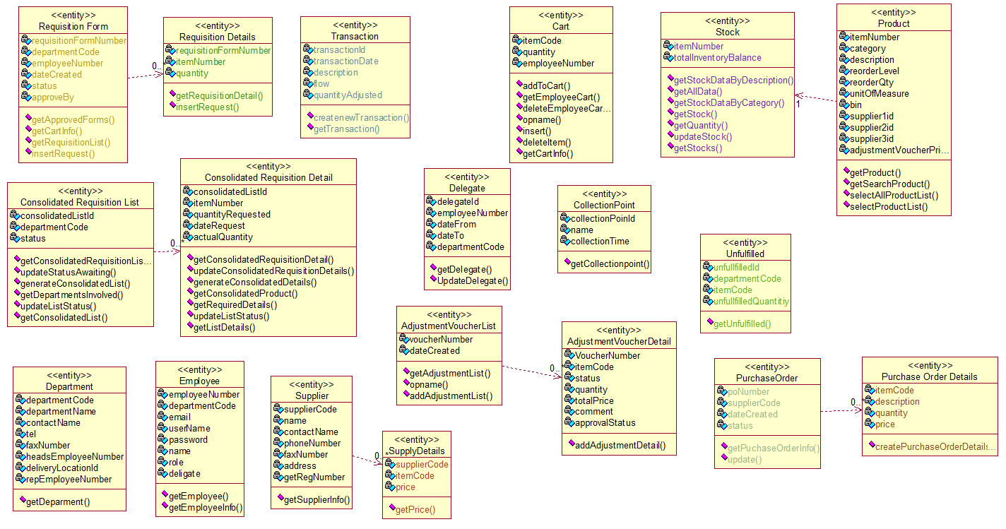

## Relational DB Design

